Predictive Modeling – WGU D208

NBM2 – NBM2 TASK 1: MULTIPLE REGRESSION FOR PREDICTIVE MODELING

Nadeem Ahmed

April 2022

**Part I: Research Question**

A: Describe the purpose of this data analysis by doing the following:

1. Summarize **one** research question that is relevant to a real-world organizational situation captured in the data set you have selected and that you will answer using multiple regression.

How much will a customer pay monthly (MonthlyCharge), and can this be predicted based on a set of predictor variables?

1. Define the objectives or goals of the data analysis. Ensure that your objectives or goals are reasonable within the scope of the data dictionary and are represented in the available data.

This is important to an organization in order to address revenue projections on a monthly, quarterly, and yearly basis. If the organization can predict monthly costs for the customer, they can also instill promotions for new/existing customers to increase referrals.

**Part II: Method Justification**

B: Describe multiple regression methods by doing the following:

1. Summarize the assumptions of a multiple regression model.

There are a few assumptions that must be met for a multiple regression model to be valid.

* A linear relationship must be present between the dependent and independent variables.
* The independent variables should not be highly correlated with each other.
* Residuals should be normally distributed.

1. Describe the benefits of using the tool(s) you have chosen (i.e., Python, R, or both) in support of various phases of the analysis.

This analysis is done using Python, Jupyter Notebook, and VSCode. The benefit of Python is the abundance of statistical and modeling packages available including pandas, scikit, seaborn, numpy, etc. They are easy to configure, and Python is a simple, yet multi-faceted programming language which can accomplish much with a few lines of code. It is fast in comparison to R, as well. Throughout the analysis, we will be conducting data cleanup, data wrangling, and data analysis. Python helps achieve these techniques and Jupyter Notebook will provide a clean and readable output which will exemplify the analysis.

1. Explain why multiple regression is an appropriate technique to analyze the research question summarized in Part I.

Multiple regression is an appropriate technique because we are conducting analysis on a continuous variable, how much money (dollars) a customer is paying on a monthly frequency. We will be able to properly distinguish the relationships between our dependent variable (MonthlyCharge) and various predictor variables. These variables will help explain the correlation they have with the target variable; and whether this relationship is positive or negative will have an impact on the effect of that predictor variable regarding corporate decision-making.

**Part III: Data Preparation**

C: Summarize the data preparation process for multiple regression analysis by doing the following:

1. Describe your data preparation goals and the data manipulations that will be used to achieve the goals.

I will begin by importing the necessary rudimentary packages like pandas, seaborn, matplotlib, numpy, and sklearn. I know that I will be using these packages for this preparation, manipulation, and analysis. Next, we’ll move to reading the data into Python via the pandas package using the read_csv command.

Once the data is available in Python, we will do an initial investigation of the data structure. Then we can examine the variable names and address any grammatical errors, improper naming conventions, potential missing data and outliers. We can replace missing values with meaningful inputs and remove outliers if necessary. We know that the target variable is MonthlyCharge. We can also make an educated guess on the predictor variables; rather what the predictor variables will not be. We will use the drop() function to remove data that is not of value to this analysis.

We will consider the continuous predictor variables and the categorical predictor variables, as well. The categorical predictor variables may need to be converted to continuous types. We’ll use histograms and other visual plots to assess the relationships and correlations between the corresponding variables.

Lastly, the customer surveys can be used in the analysis to help make sense of what services are delivering value to the company.

1. Discuss the summary statistics, including the target variable and *all* predictor variables that you will need to gather from the data set to answer the research question.

After running a few simple commands like info() and describe() we see that the dataset contains 50 columns and 10,000 records. The target variable is MonthlyCharge. There are a few columns that can be removed from the dataset because they will not contribute to the correlation to monthly charge. This includes 'CaseOrder', 'Customer_id', 'Interaction', 'UID', 'County', 'Lat', 'Lng', 'Population', 'Area', 'Timezone', ‘City’, ‘State’, and 'Job'. That leaves 37 columns with 10,000 rows. Out of those 37, one is MonthlyCharge, so there are a possible 36 predictor variables for our target variable.

1. Explain the steps used to prepare the data for the analysis, including the annotated code.

* Import the necessary Python Packages.

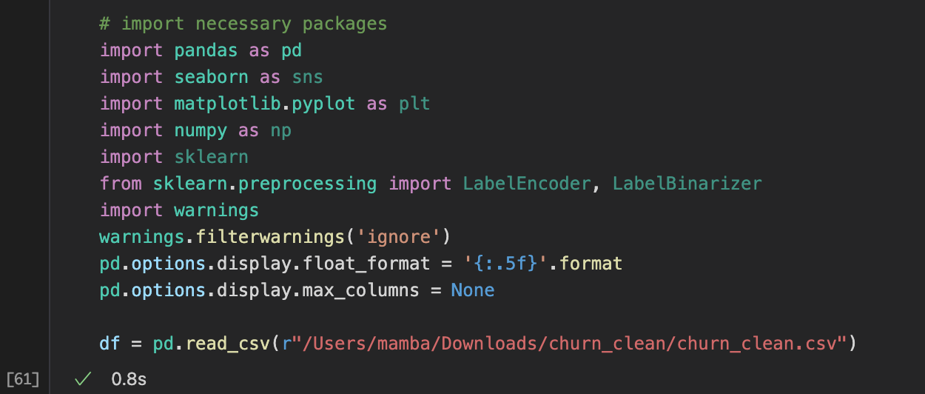

* Understand the raw dataframe

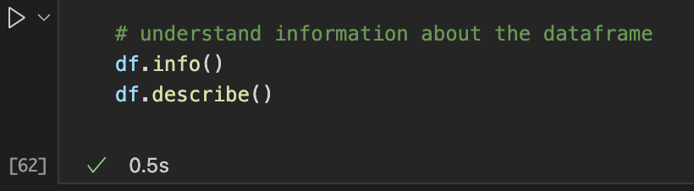

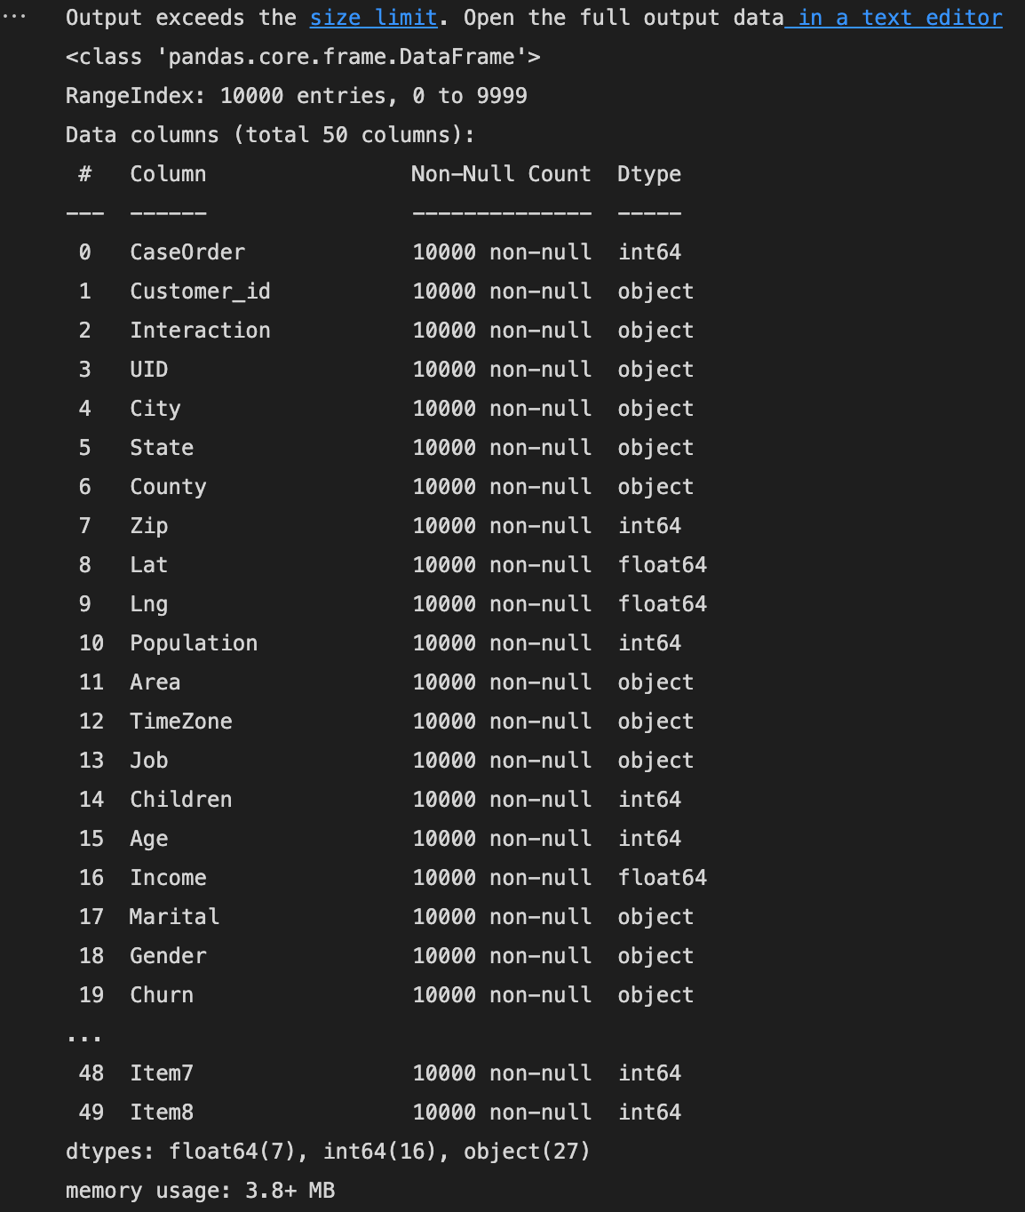

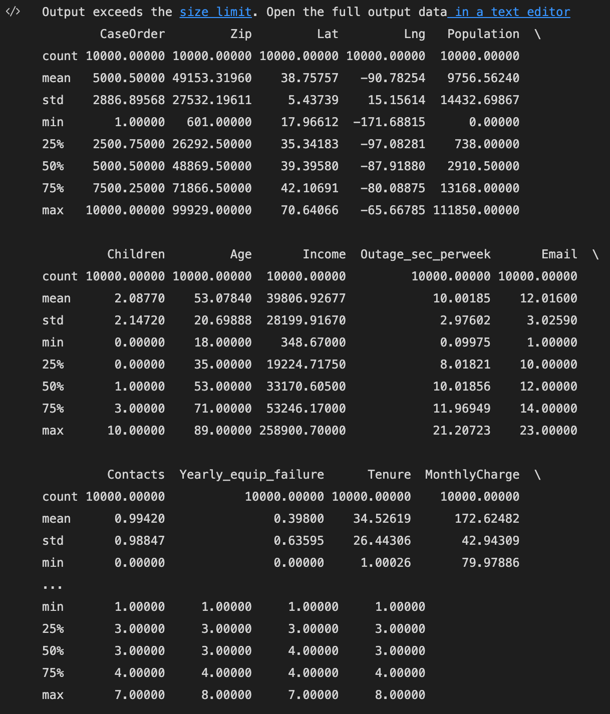

* Rename any columns that could assist with understanding the dataframe

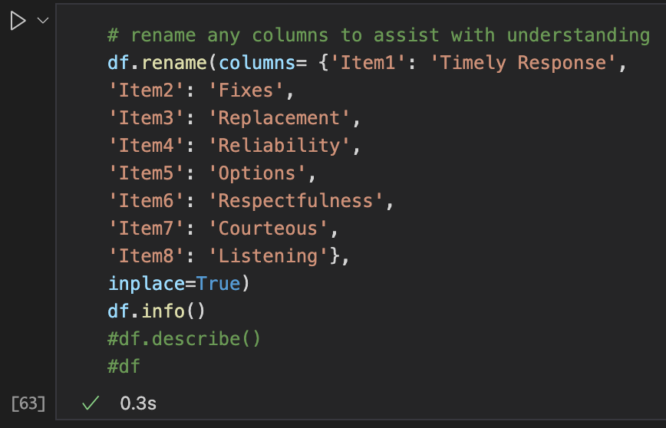

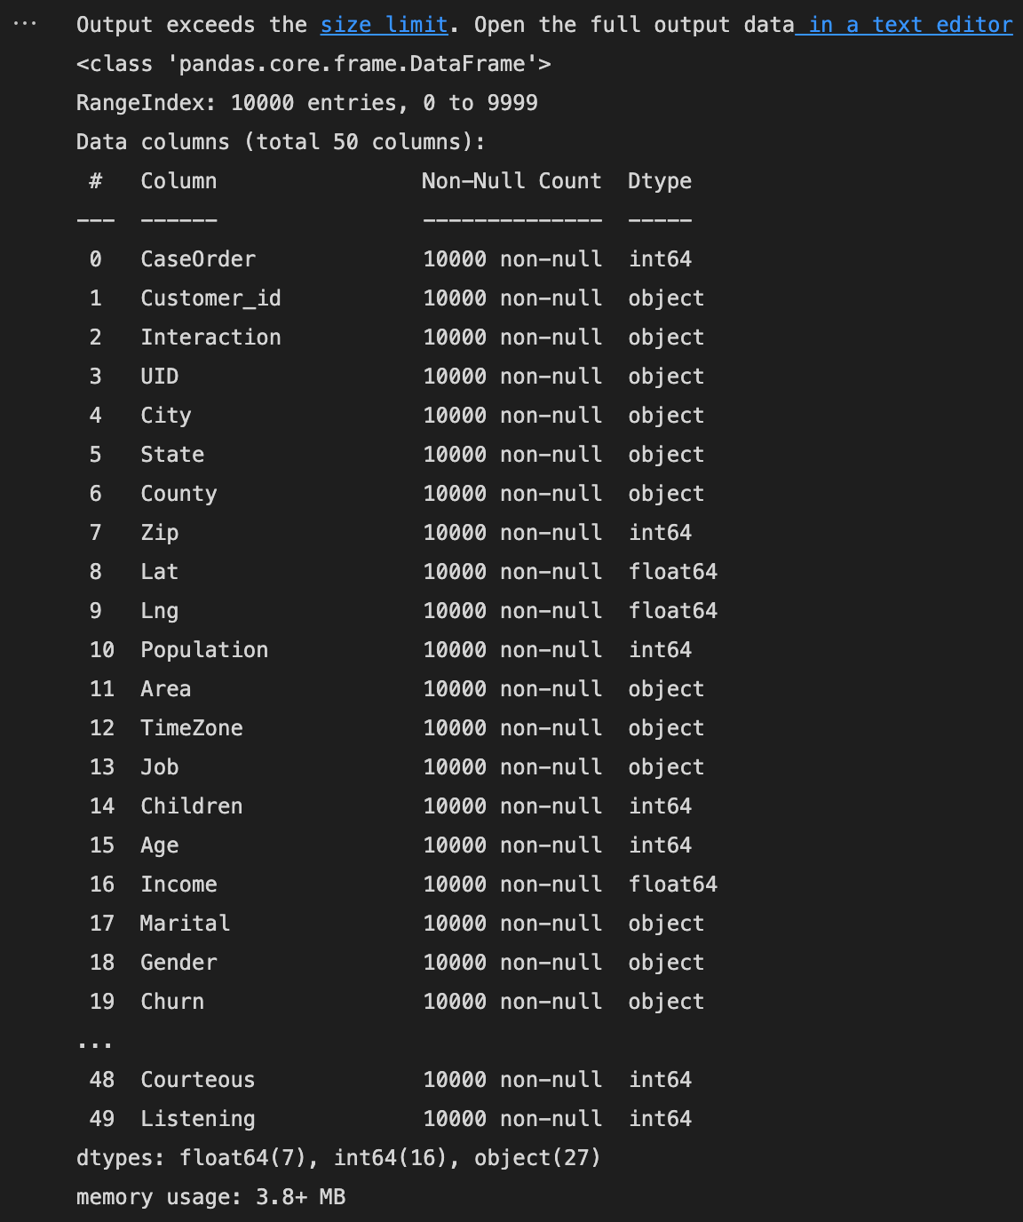

* Create a different dataframe for the columns

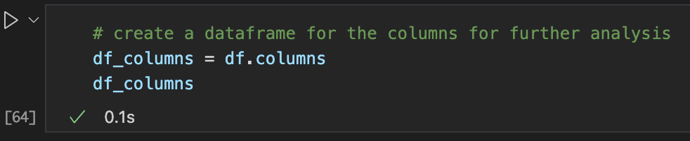

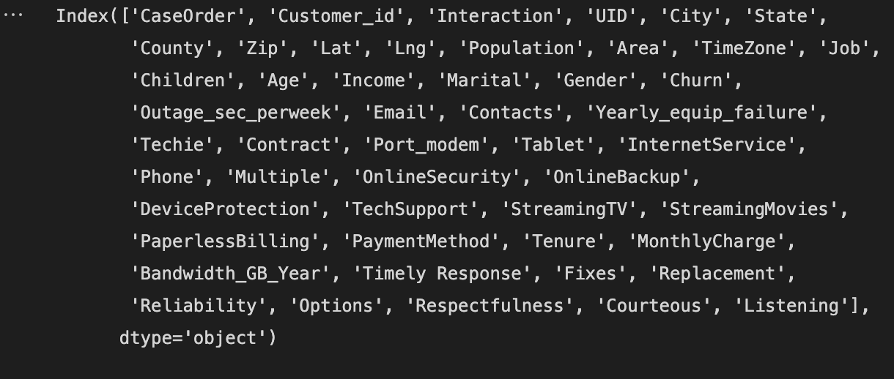

* Remove any variables that will not assist in the correlation analysis to the target variable

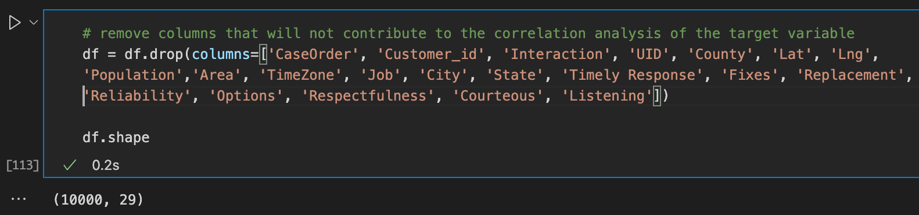

* Explore the dataset for any missing data, null values, and duplicates. We will also look for outliers after this.

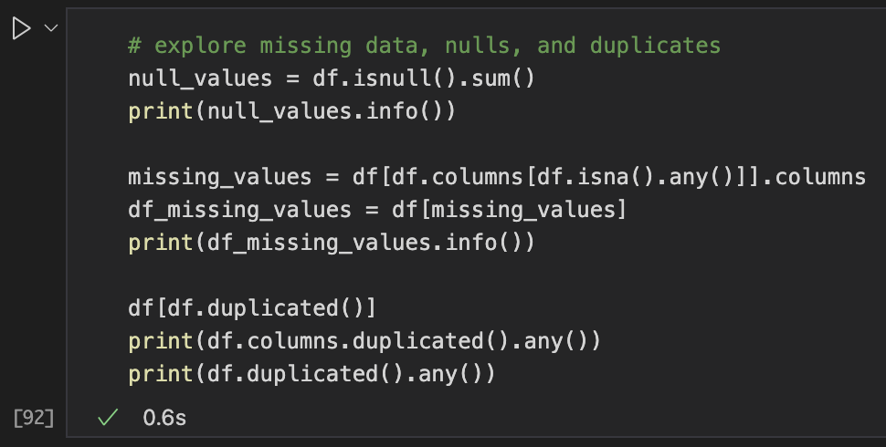

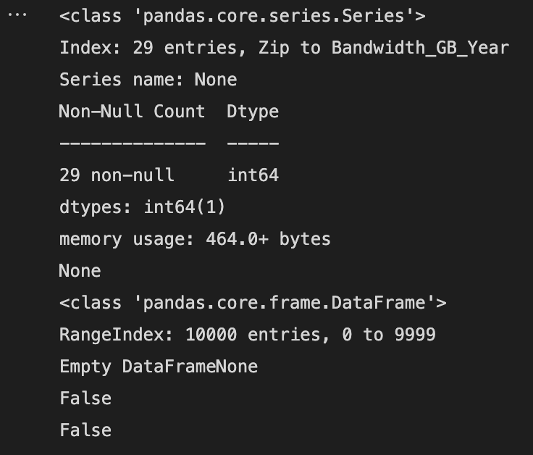

The data set shows no missing, null, or duplicate values. This is a clean dataset which is ready for analysis.

* We then look at the dataset to determine how many numerical variables there are vs how many categorical variables there are.

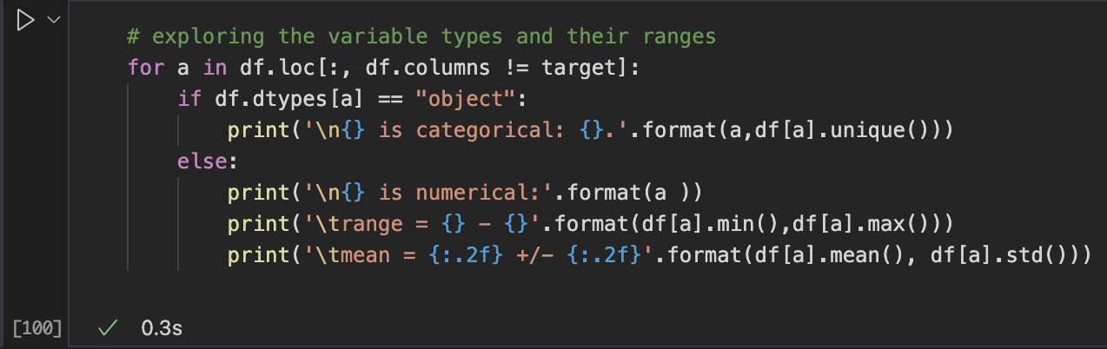

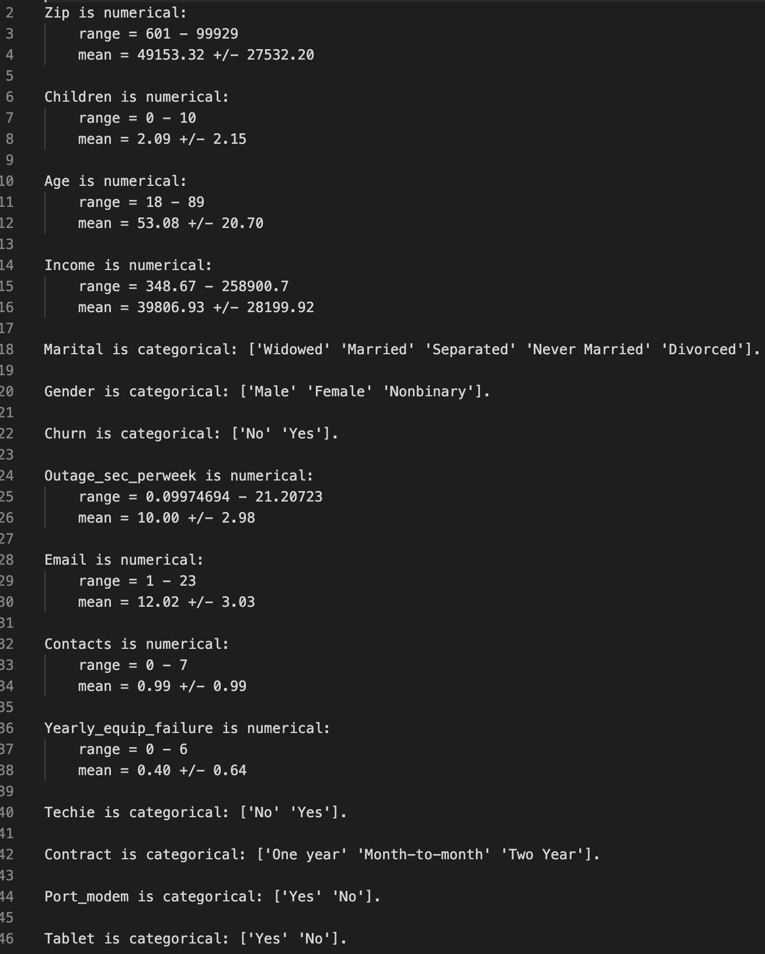

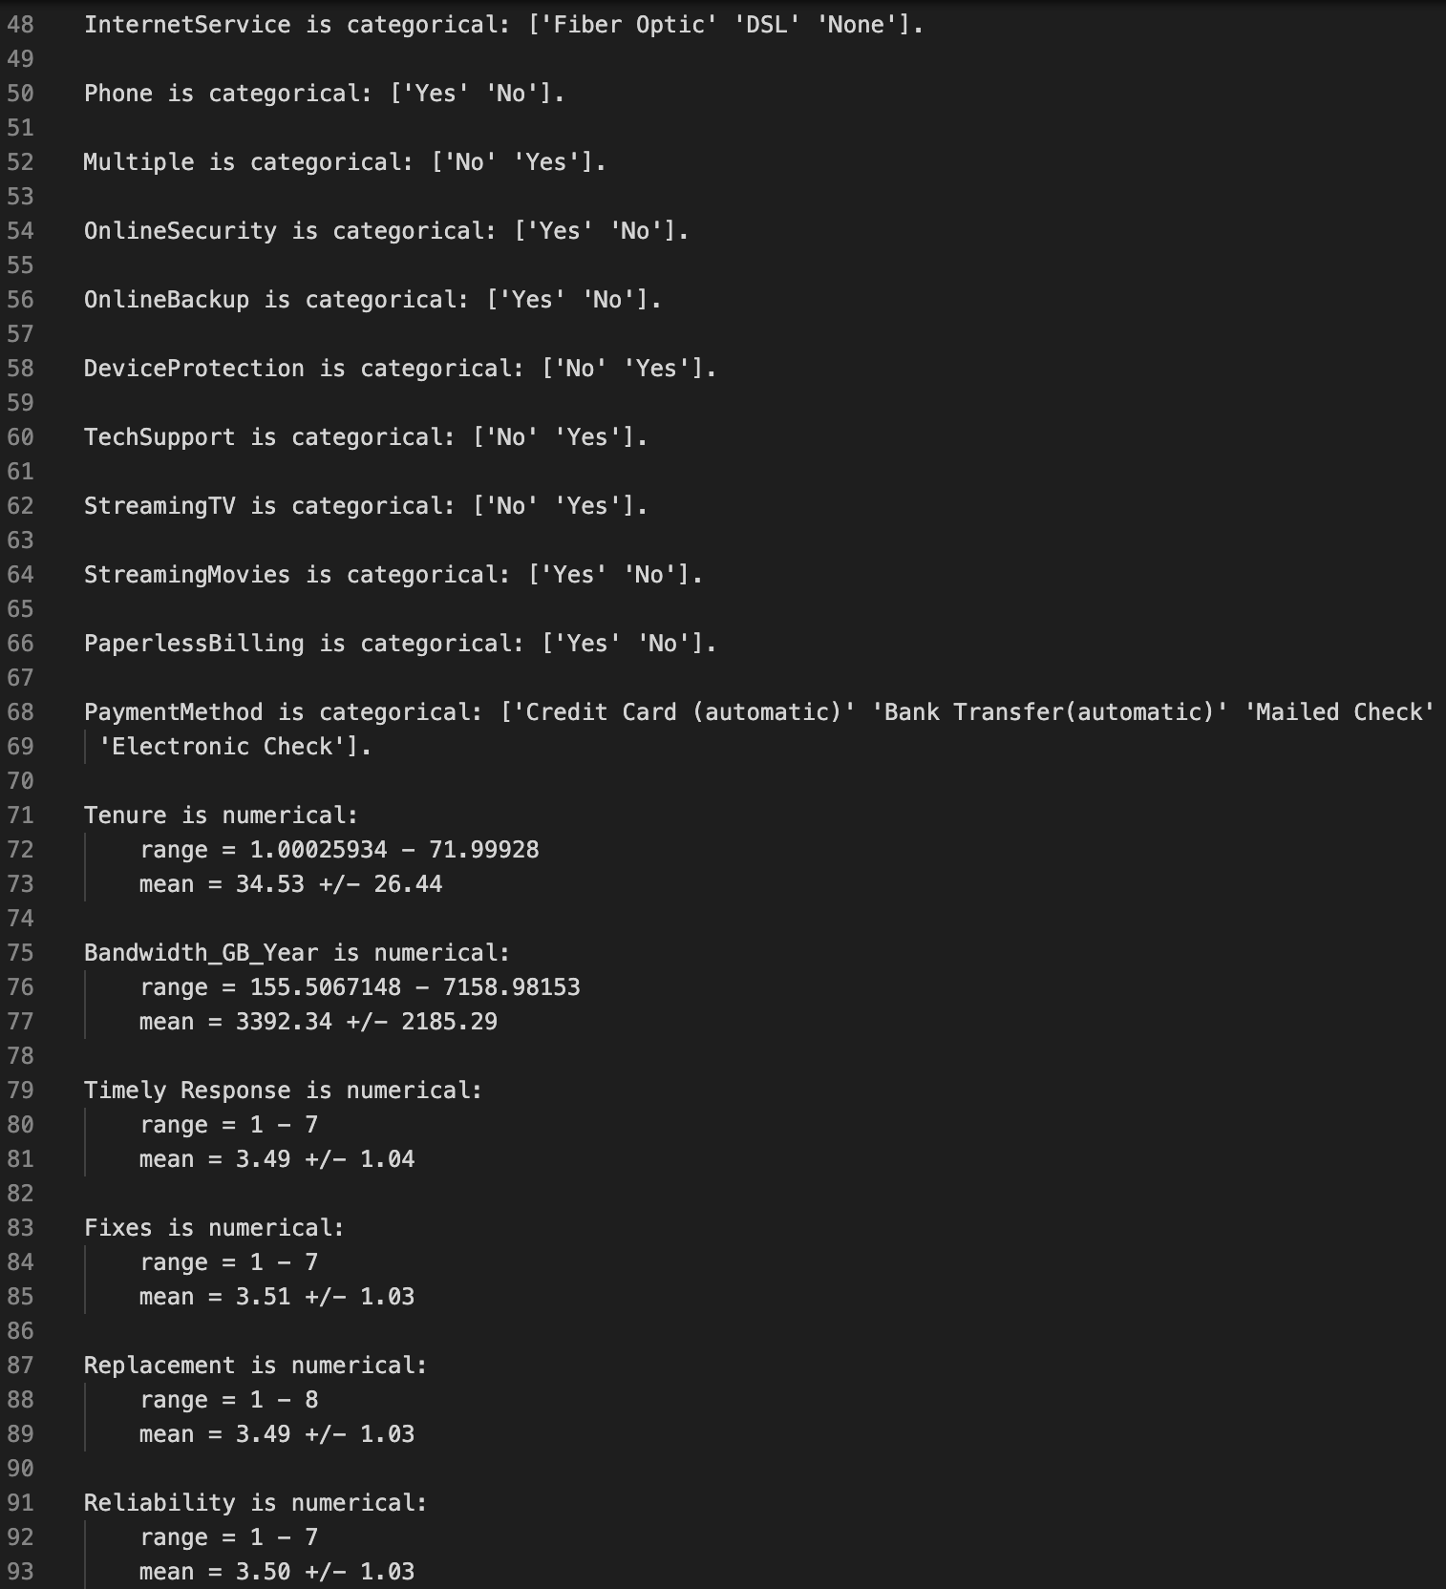

We notice that besides the 8 survey variables, we have 10 numerical variables and 18 categorical variables, outside of the target variable, ‘MonthlyCharge’.

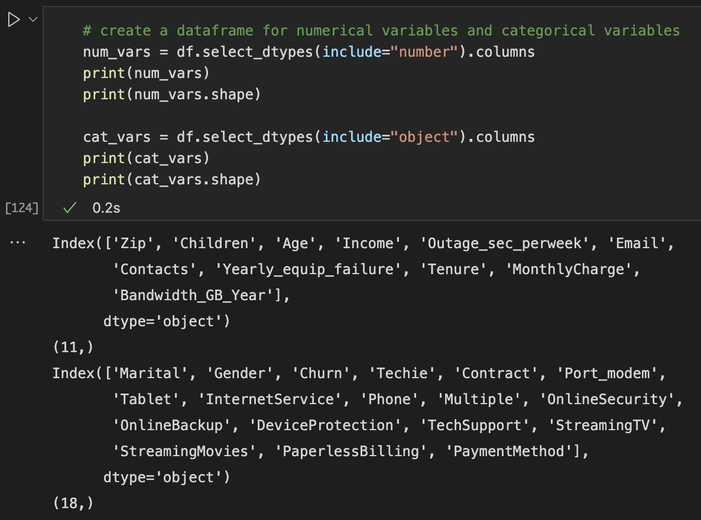

This gives us a clearer understanding of the variables that are numerical, and which are categorical.

The categorical values will need to be converted to numerical to conduct a proper univariate, bivariate and regression analysis

* We use the getdummies() pandas function to create dummy variables as numerical types if the variable was in the cat_vars dataframe.

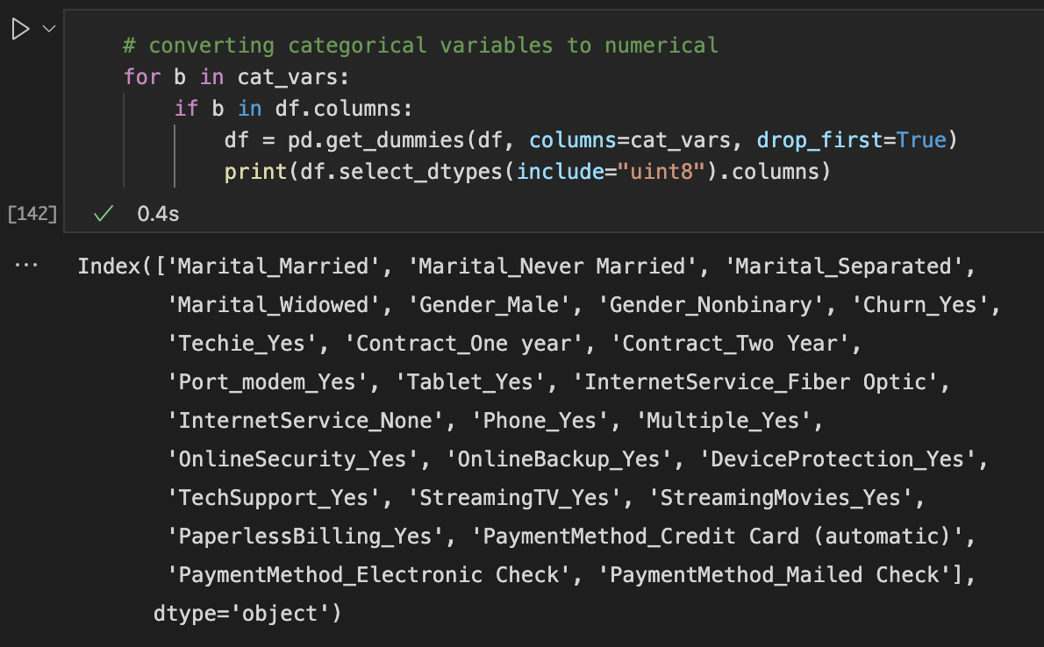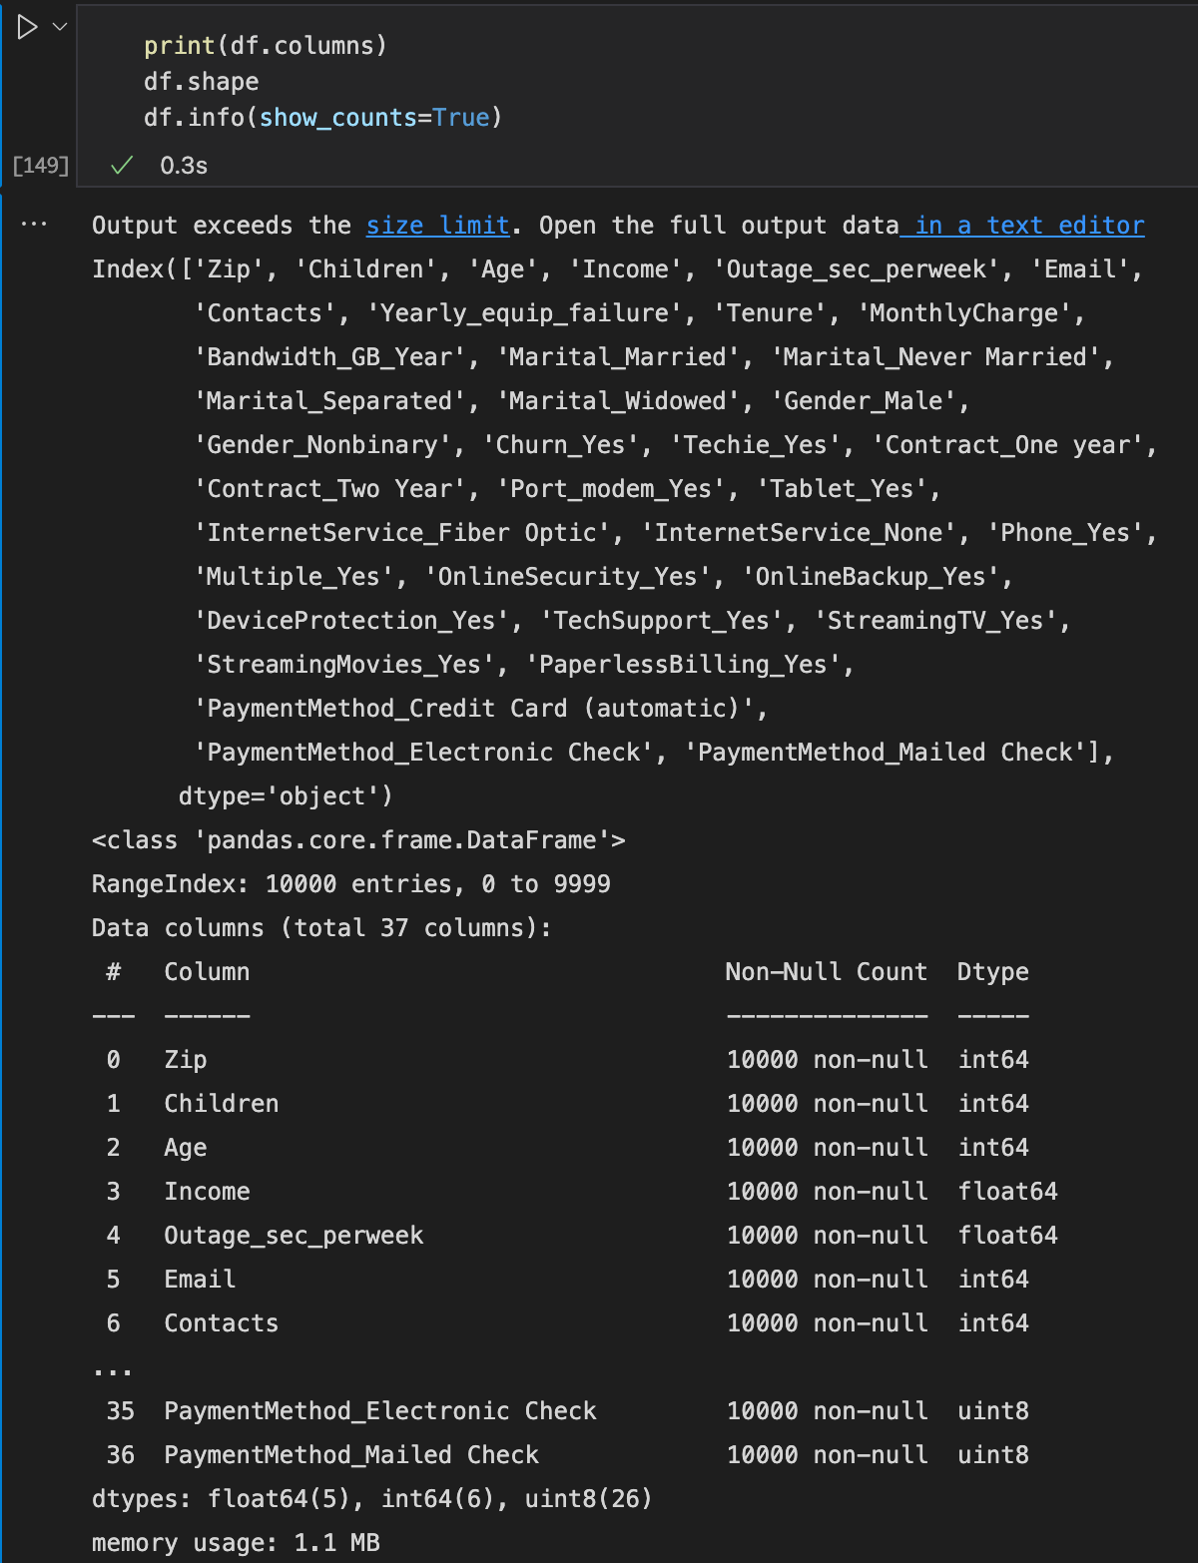

The summary statistics show that all the variables are numeric types (float, int, or uint).

1. Generate univariate and bivariate visualization of the distributions of variables in the cleaned data set. Include the target variable in your bivariate visualizations.

For univariate visualizations, we create histograms and boxplots of the continuous variables.

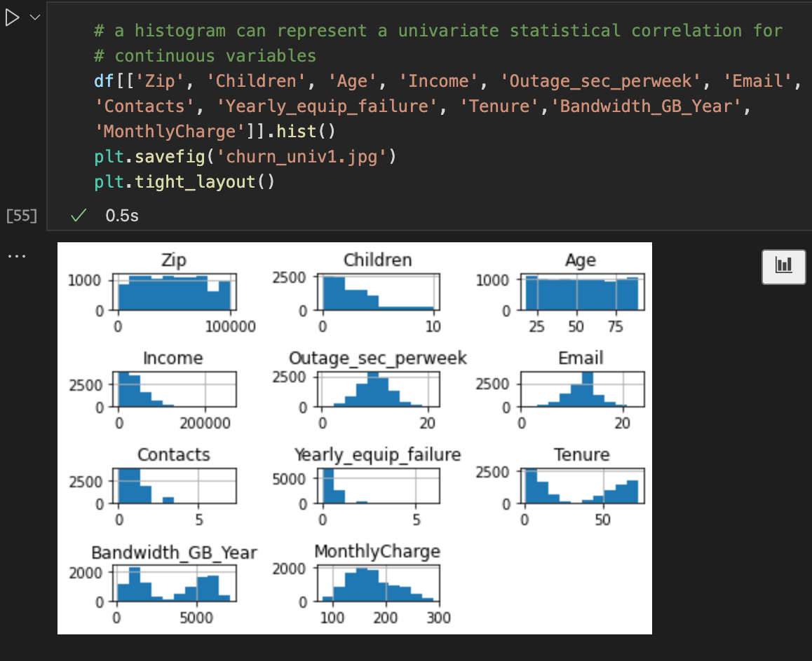

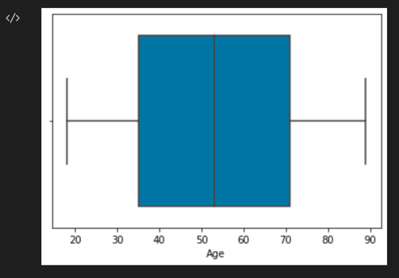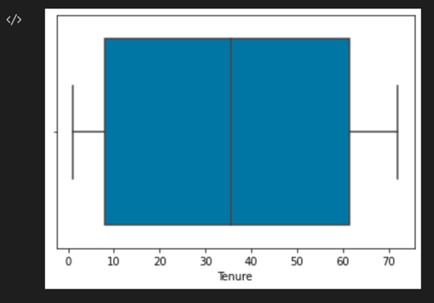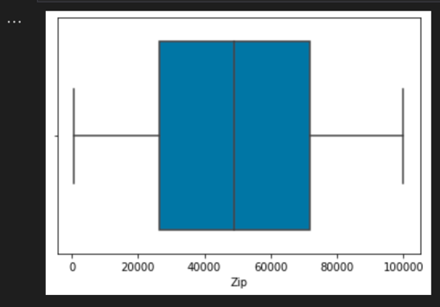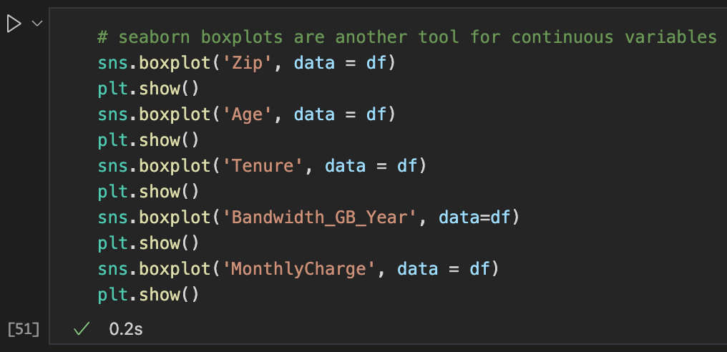

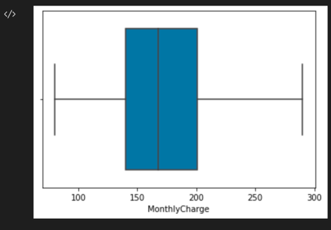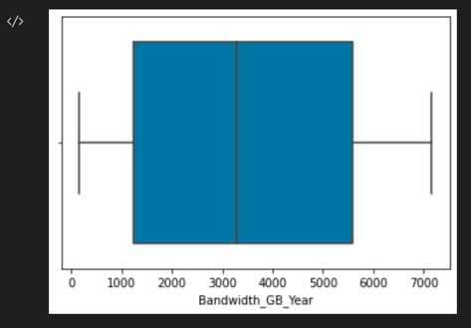

For bivariate visualization, we will create a seaborn scatterplot and pairplot.

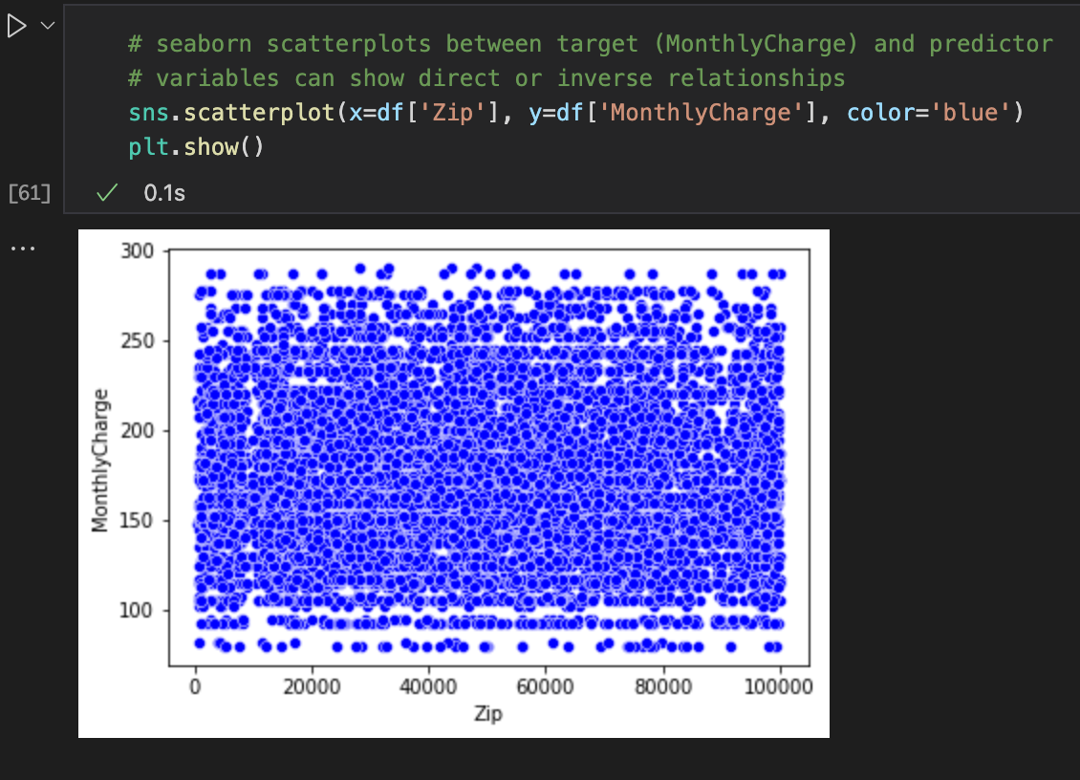

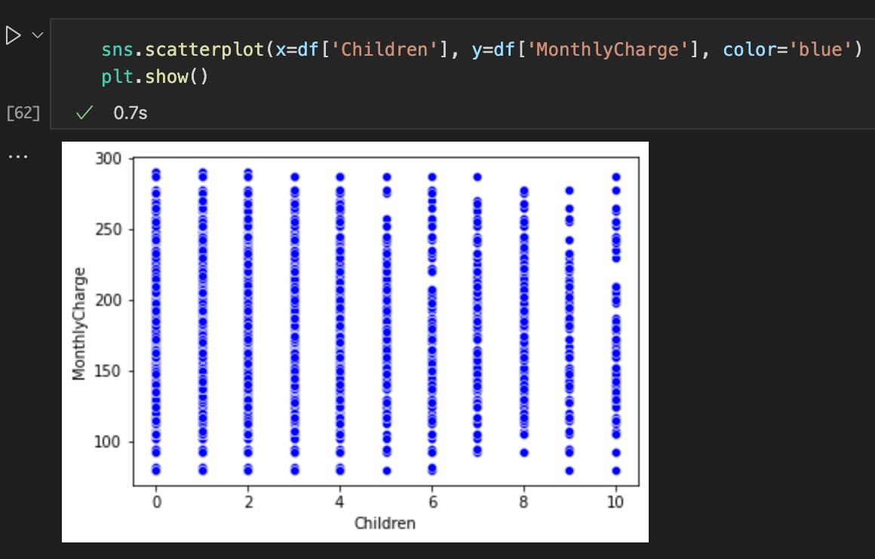

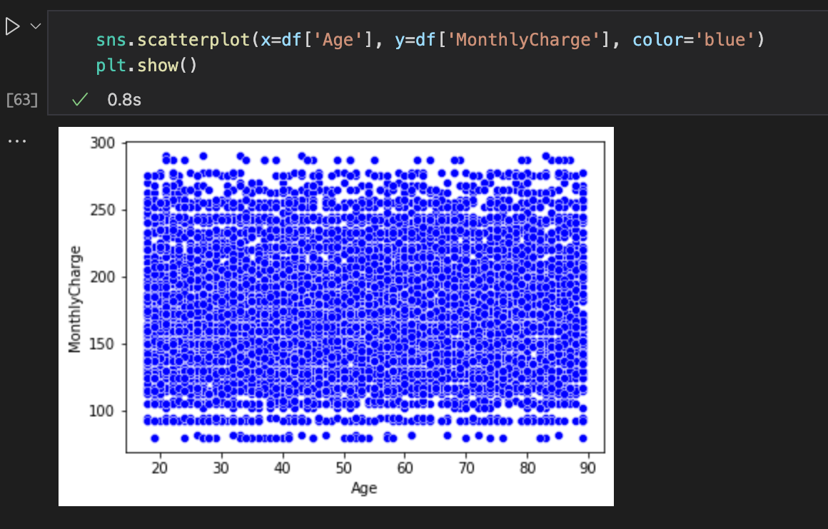

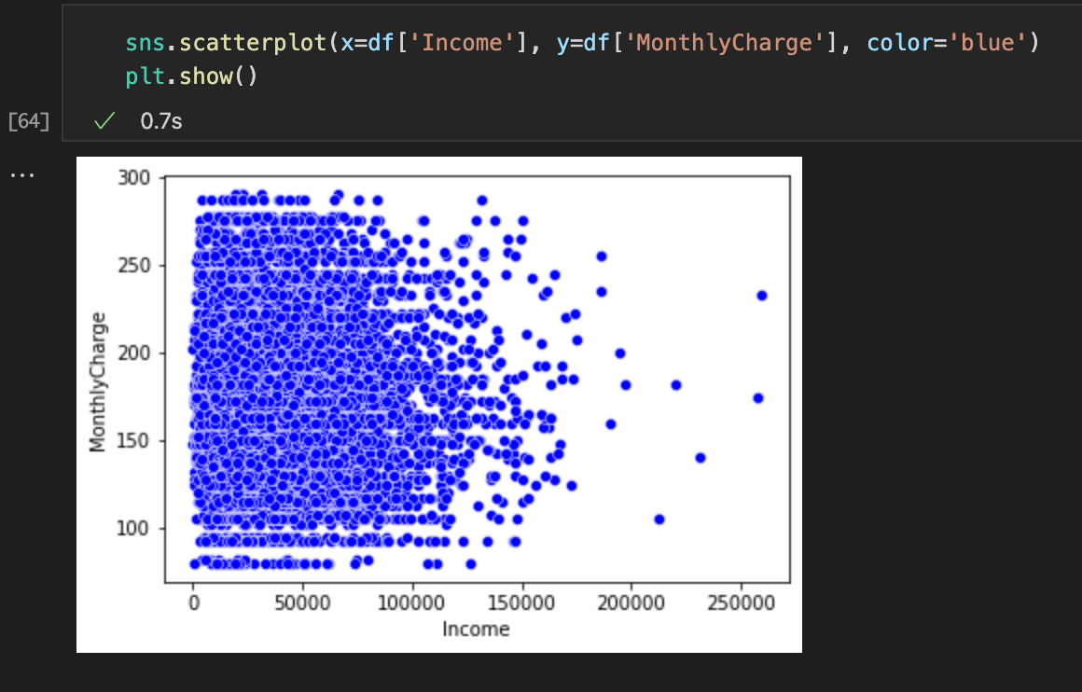

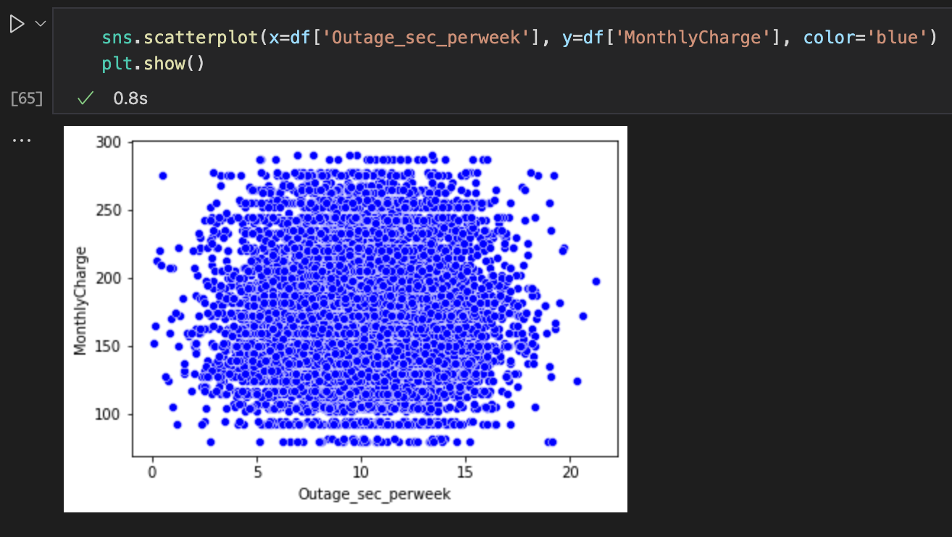

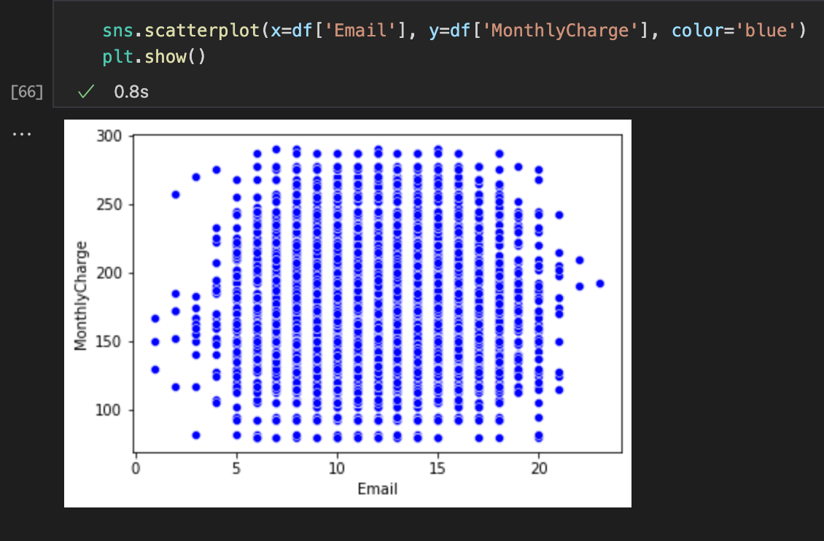

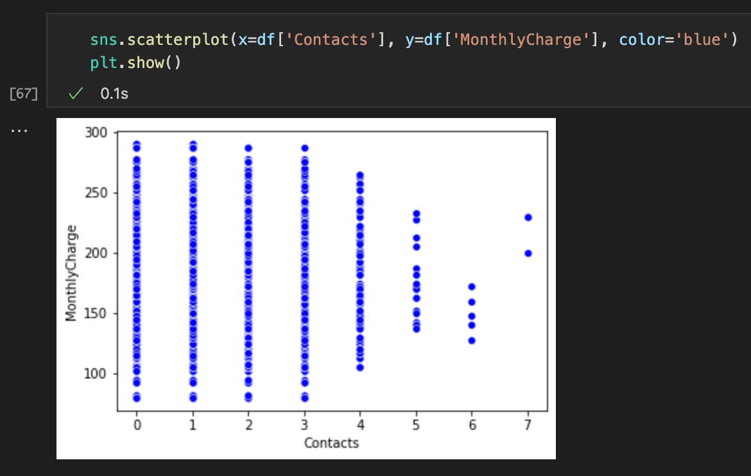

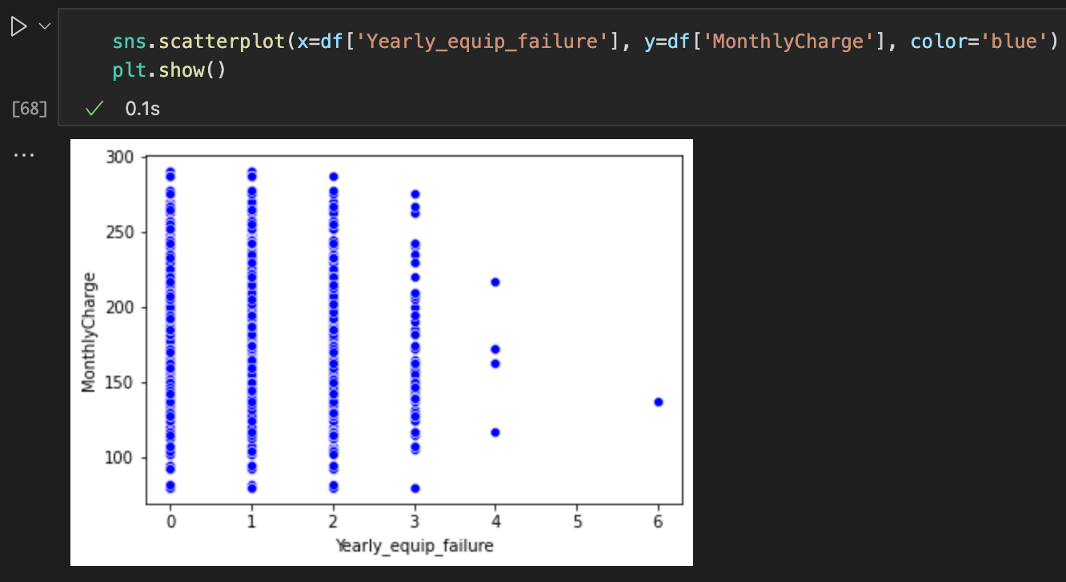

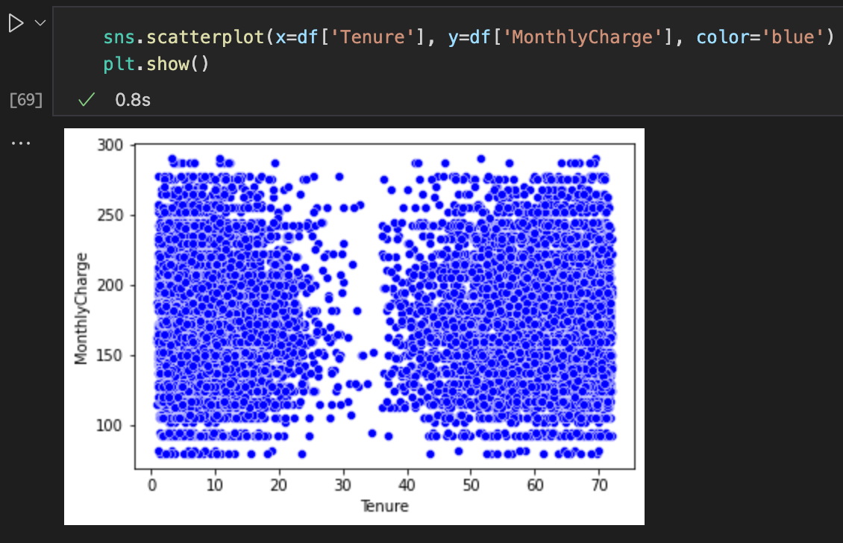

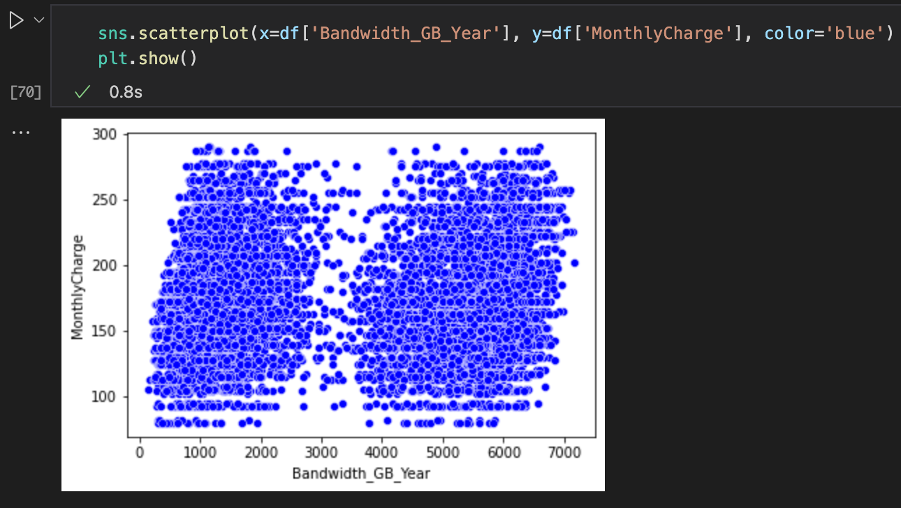

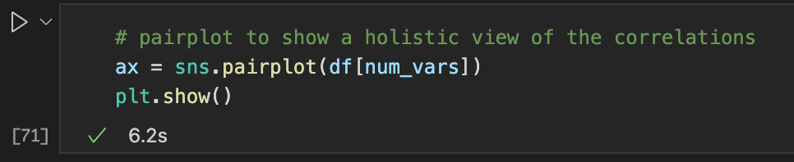

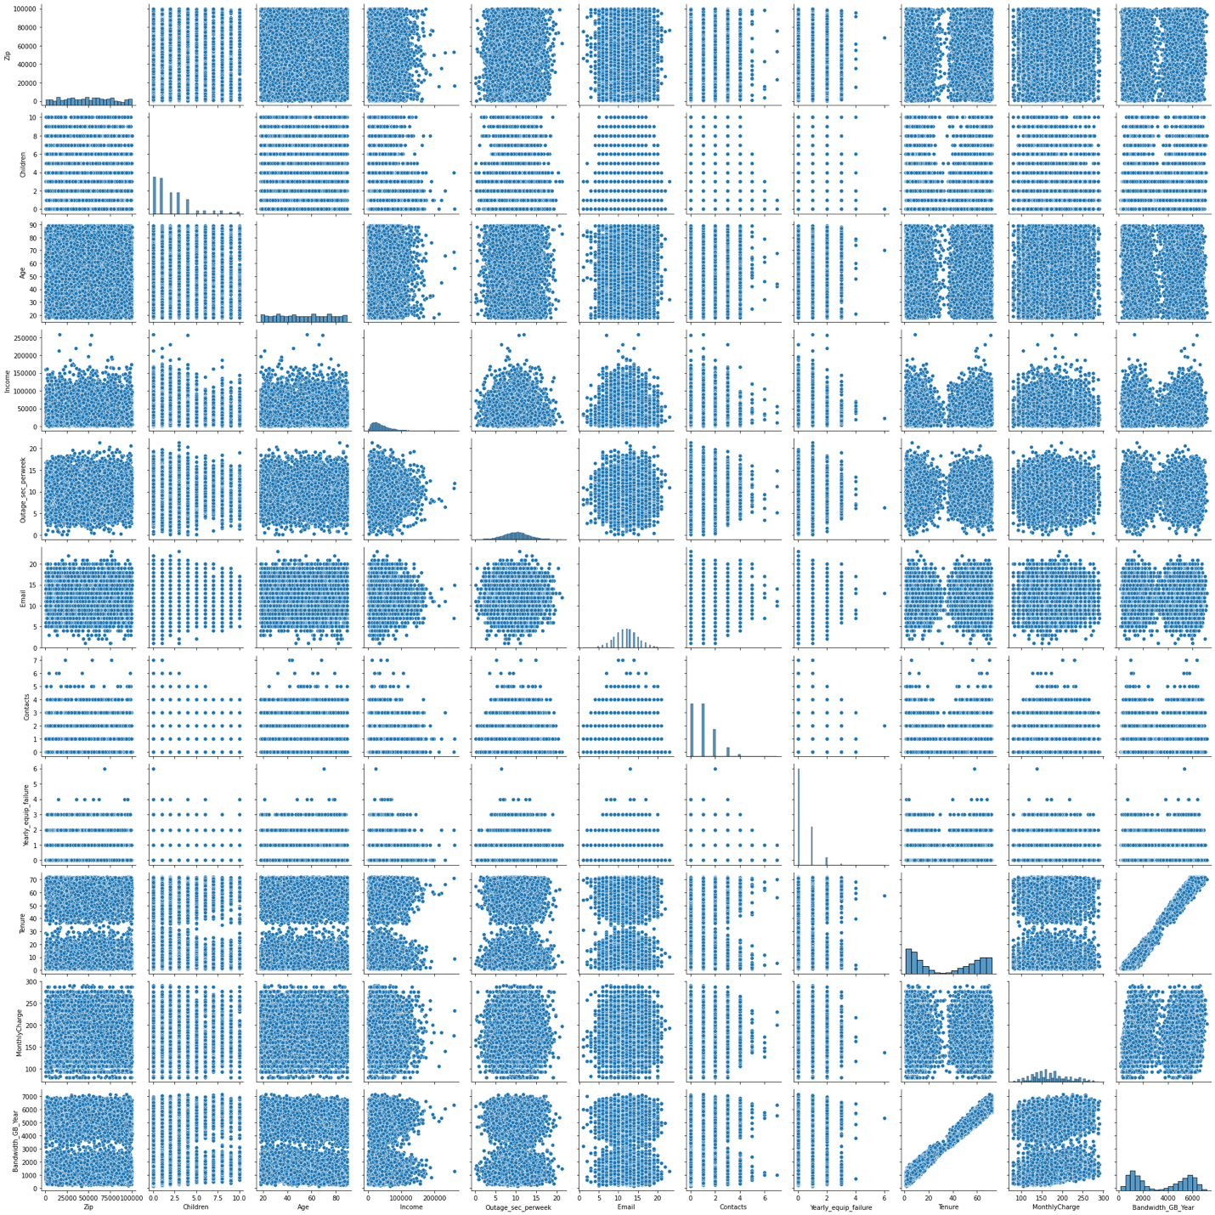

The only relationship that really sticks out is the linear relationship between Tenure and Bandwith_GB_Year. This represents multicollinearity and the multicollinearity cannot be part of the regression model so we will remove this correlation from it.

1. Provide a copy of the prepared data set.

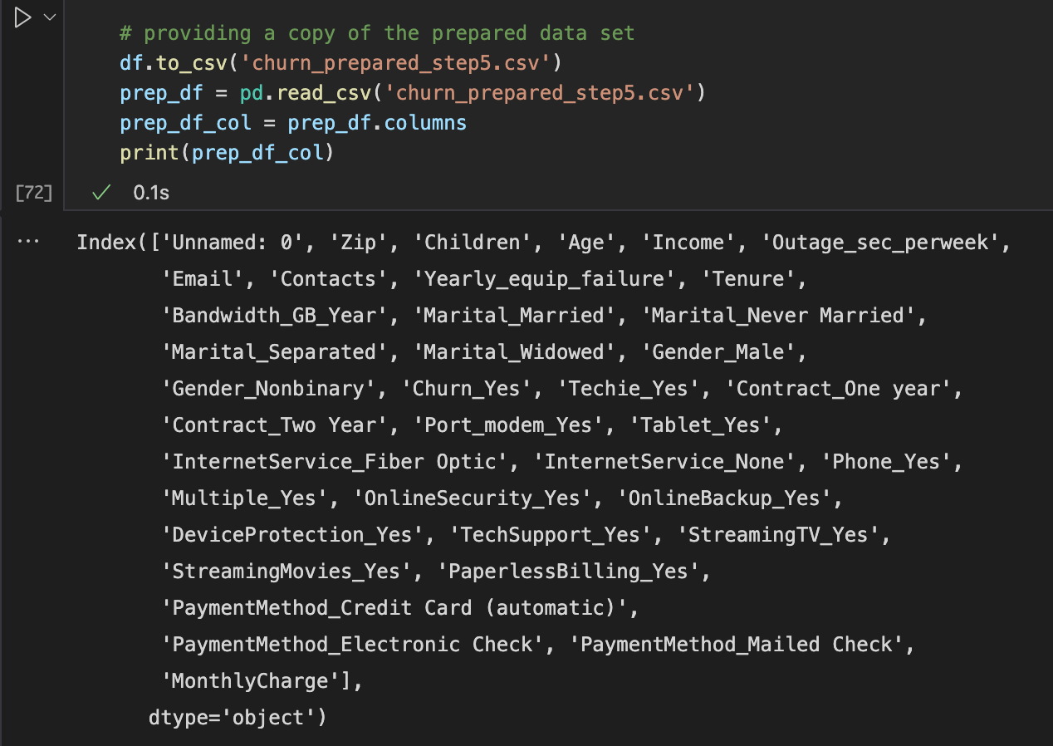

**Part IV: Model Comparison and Analysis**

D: Compare an initial and a reduced multiple regression model by doing the following:

1. Construct an initial multiple regression model from *all* predictor variables that were identified in part C2.

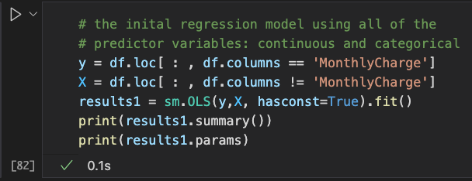

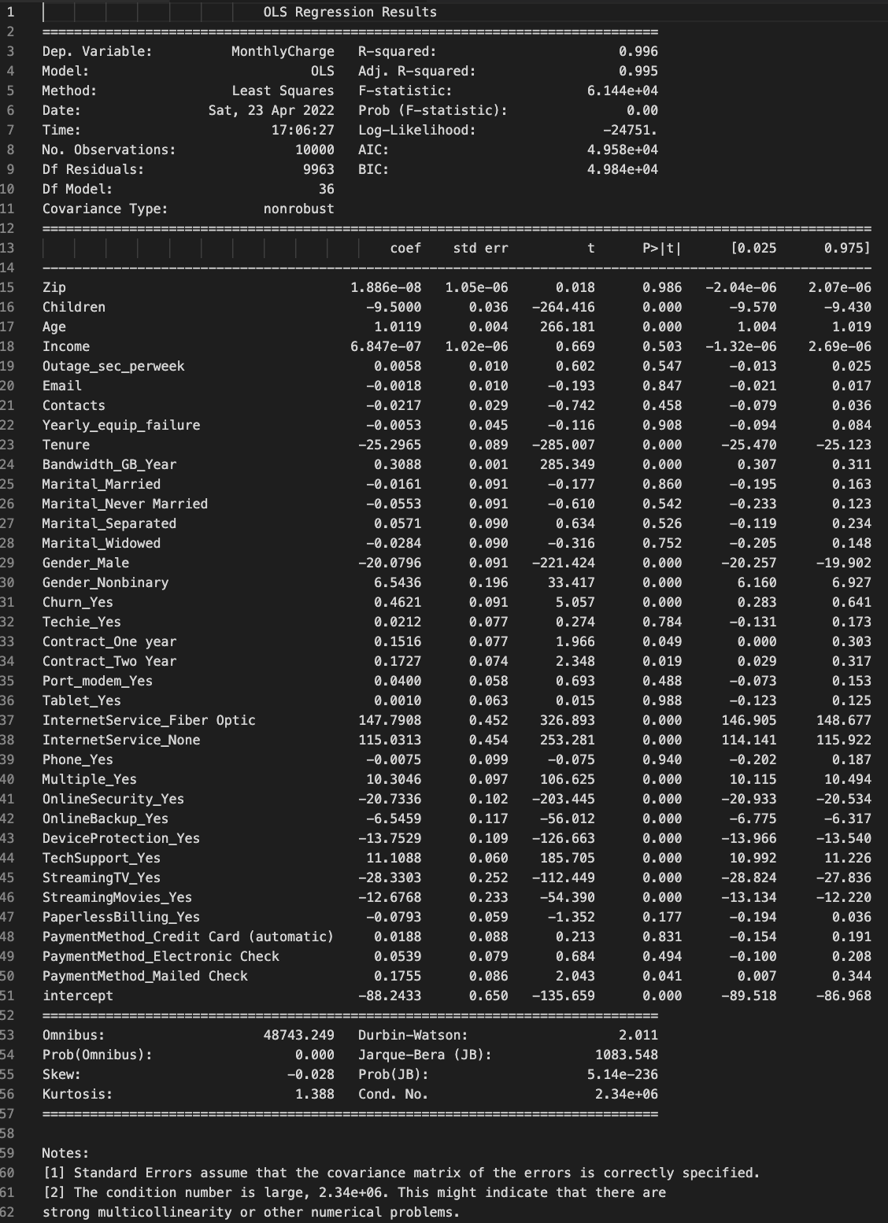

Here are the parameter intercepts:

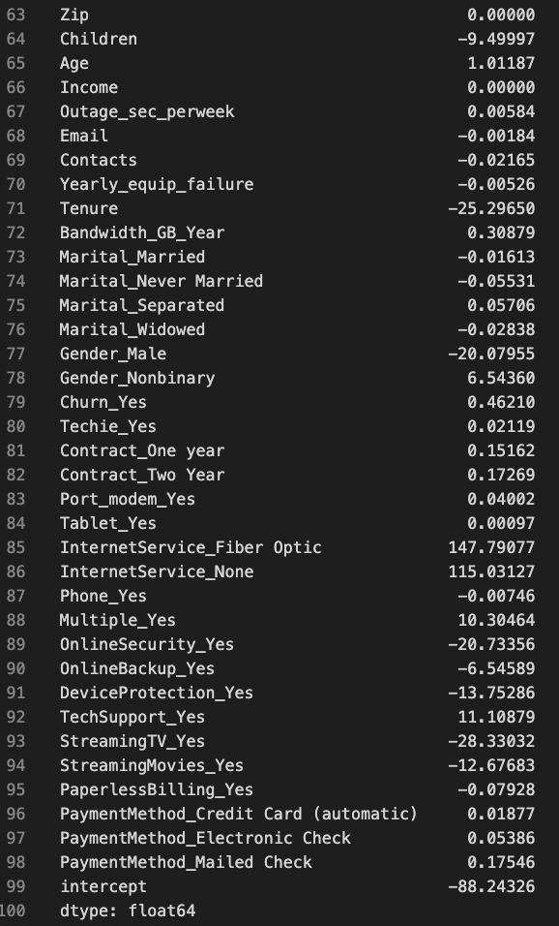

There are 26 categorical variables and 10 numerical variables in this model that are possible predictor variables. The R2 value = 0.996 which means that this model can explain 99.6% of the variability. The OLS summary results also show in the notes there this is a large condition number, 2.34e+06, which may indicate strong multicollinearity between variables. The variables have high p-values as well. This must be resolved to have a proper multiple regression model.

This means that some of the variables are extraneous to the regression fit, which makes sense. The monthly charges probably are not correlated to zip code, children, age, or income. I was trying to see if maybe there was a correlation in the subset of the customer base that was being charged specifically based on their location or their family structure. These variables probably won’t help in explaining the variance. The services that customers purchase are going to be the main driving factor that explain the variance in this model. We can create heatmaps to reduce the variables.

1. Justify a statistically based variable selection procedure and a model evaluation metric to reduce the initial model in a way that aligns with the research question.

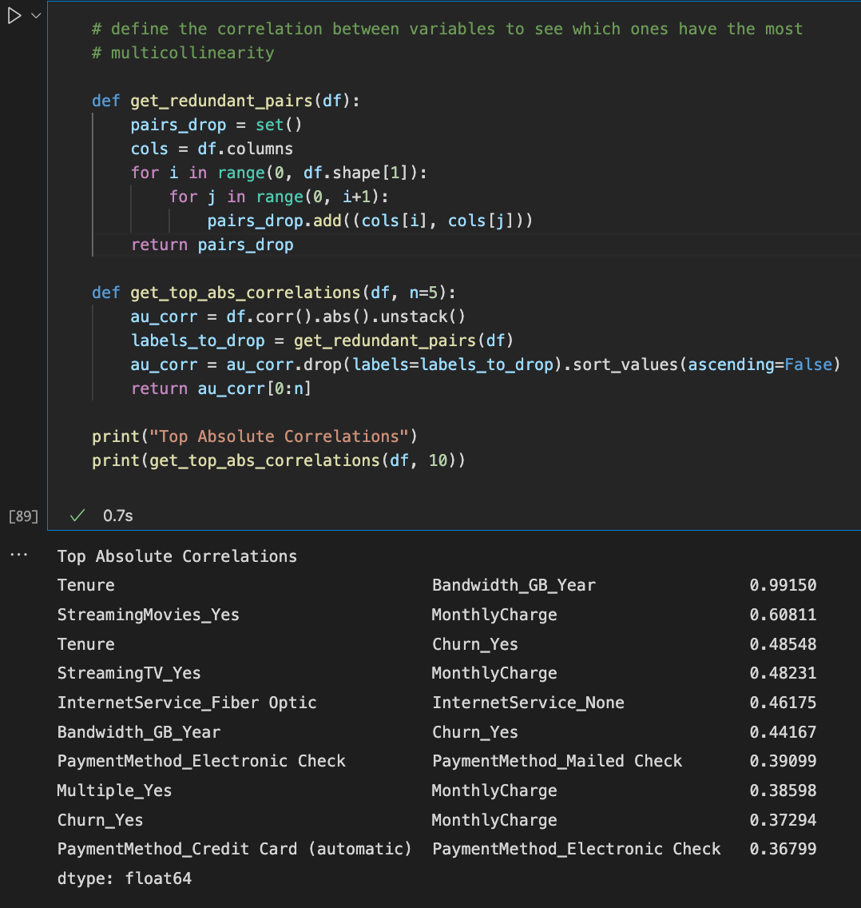

This correlation analysis shows a high correlation between Tenure and Bandwidth_GB_Year.

Next, we can create a seaborn heatmap which will help visualize the correlations between all the variables.

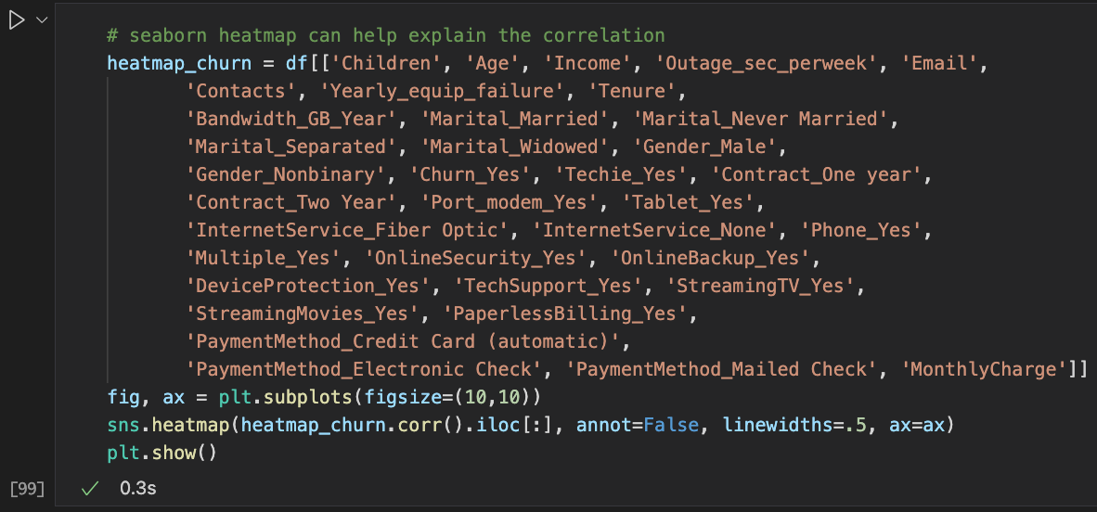

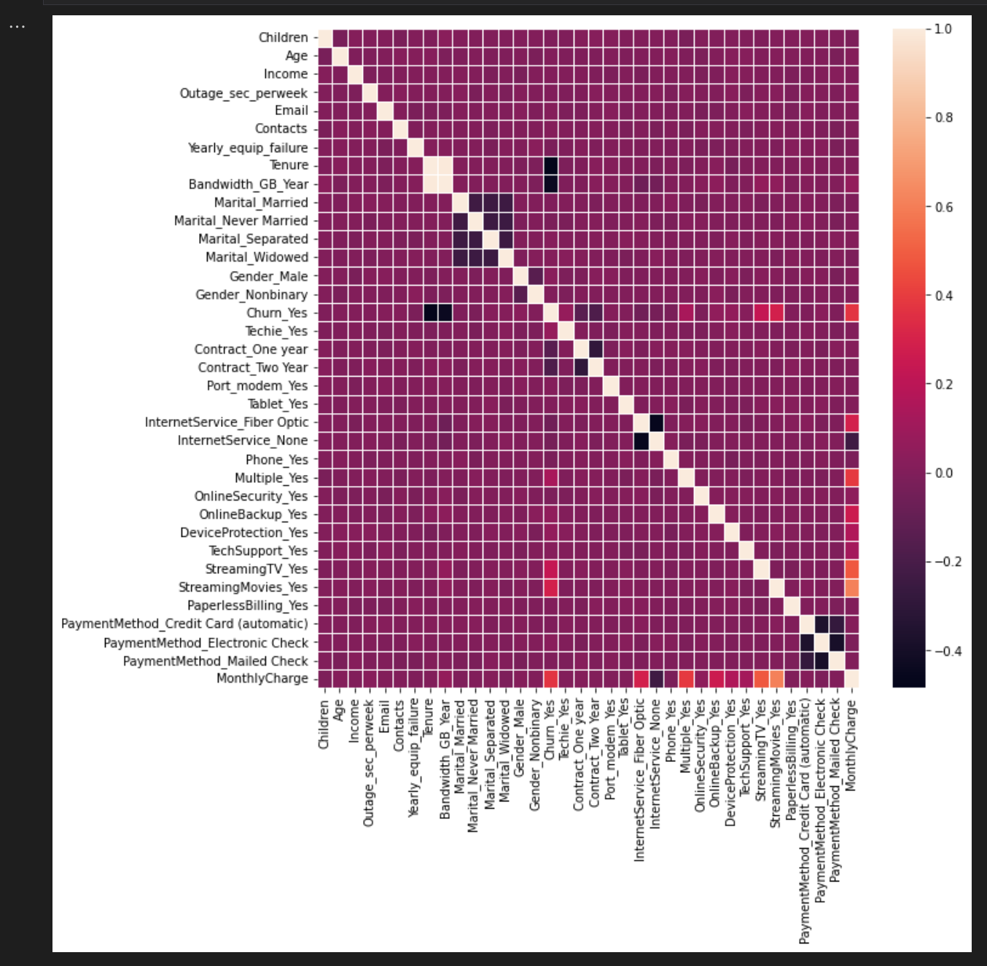

This correlation shows that the services that customers have bought have a clear impact on the monthly charges, which makes sense. We can get rid of the some of the variables that are negligible in the analysis and have high p-values as well.

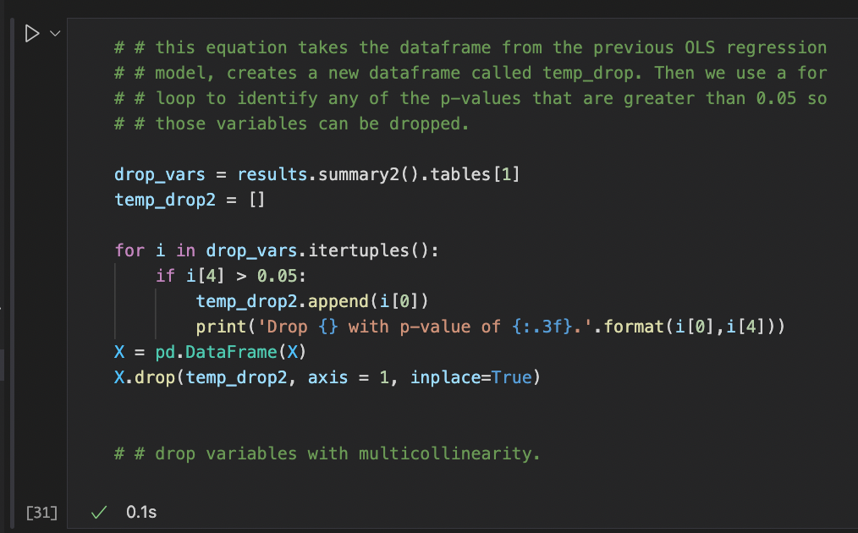

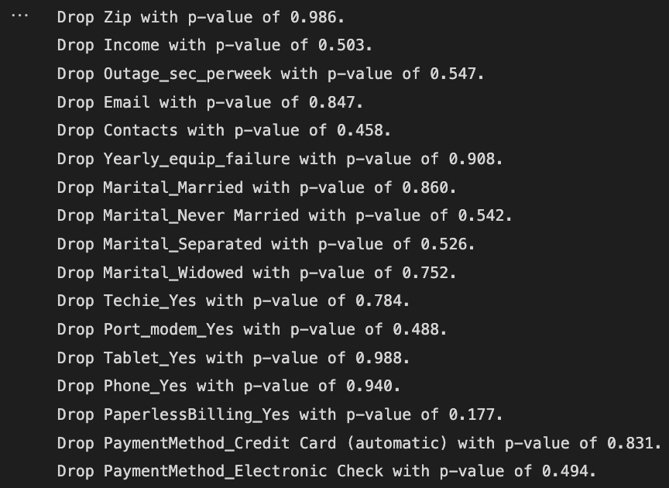

We dive deeper and remove the variables that were highly correlated with one another. We remove the multicollinear variables from the model.

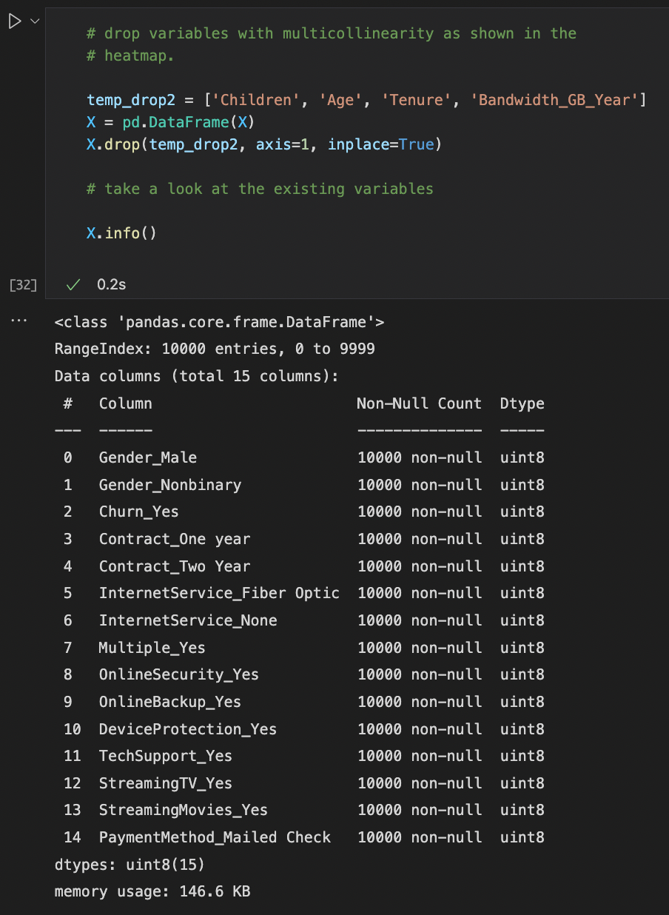

1. Provide a reduced multiple regression model that includes *both* categorical and continuous variables. (Note: The output should include a screenshot of each model.)

We are left with 15 variables of which all are categorical variables. The OLS regression model is run again with this new data model to see if it is a fit.

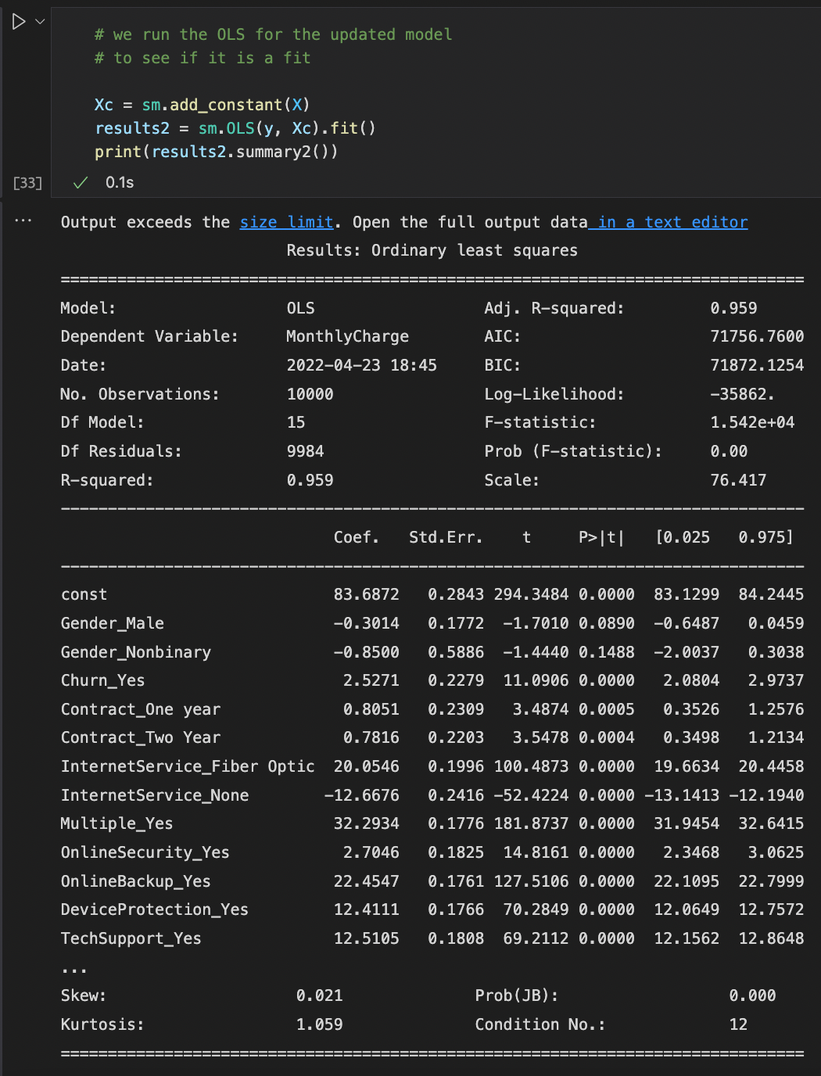

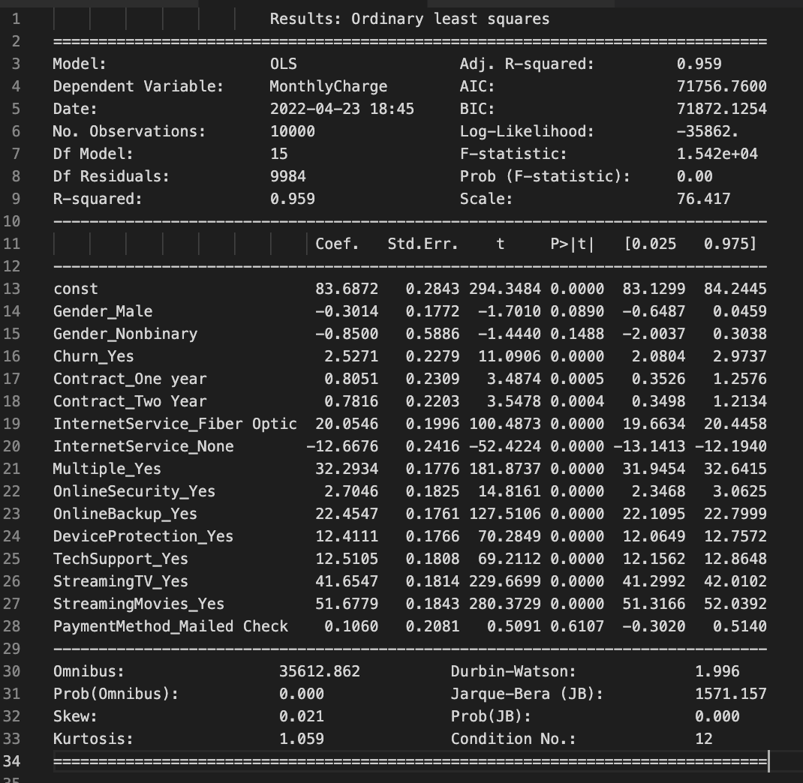

The model shows 0.959 as the R2 value which means that 96% of the variance can be explained by this model. That’s a good fit, but we can make some minor changes by reducing the variability a bit more.

The reduction is done once more to remove any variables that are extraneous and can be removed to provide a valid model which can explain variance with a viable R2 value.

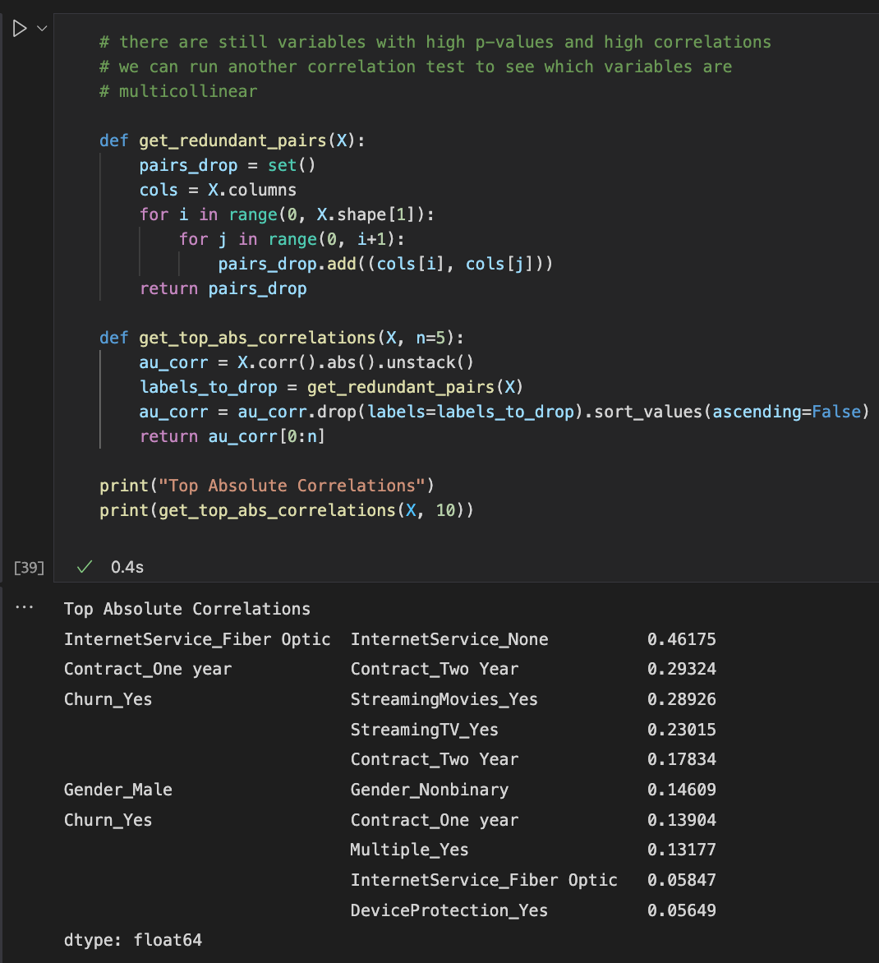

The p-values were high for the gender variables and the PaymentMethod_Mailed Check variable. We will remove those. The others that stand out which are multicollinear and from a business standpoint probably don’t affect monthly charges are InternetService_None and Churn_Yes.

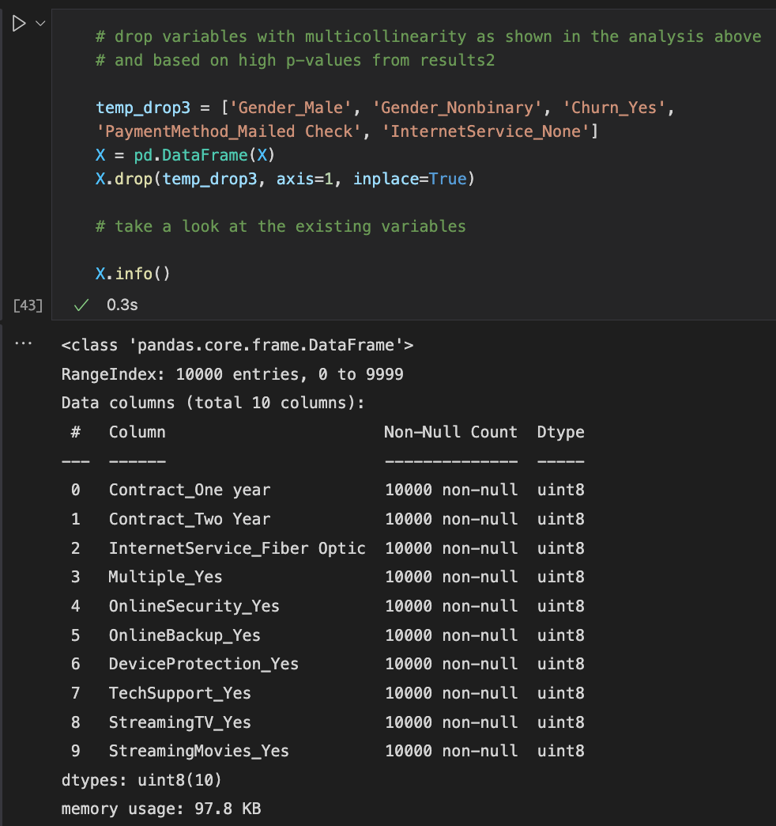

We are left with 10 variables. We will do another OLS model fit test to see if these variables can explain with a probability the variance.

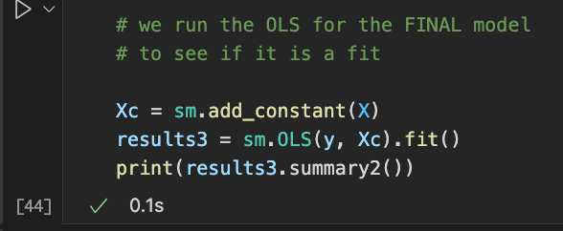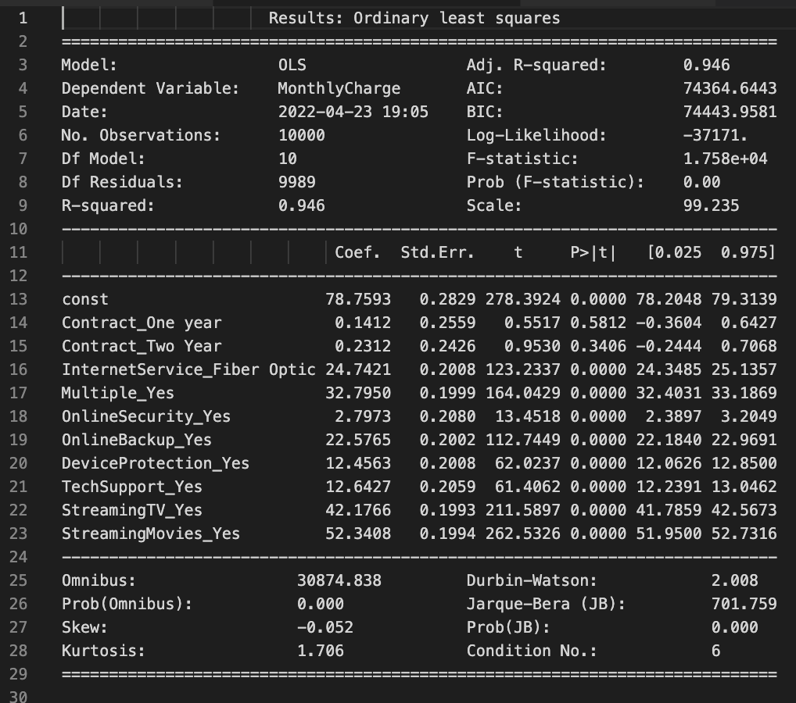

This model fits! We have a R2 value of 0.946 which means that 95% of the variance can be explained by this model.

E: Analyze the data set using your reduced multiple regression model by doing the following:

1. Explain your data analysis process by comparing the initial and reduced multiple regression models, including the following elements:
   * The logic of the variable selection technique
   * The model evaluation metric
   * A residual plot

The variable selection for reduction was done by assessing the p-values of the variables and any multicollinearity. For a fitting multiple regression model, we want to limit variables with high p-values and those with high multicollinearity. The OLS summary presented all the variables in that model alongside the p-values and the R2 values.

We began with 36 predictor variables.

In the results1 OLS summary report we had a 99% fitted model (R2 value = 0.996) and 17 variables with high p-values. We also had 4 other variables with multicollinearity shown through a correlation chart and a heatmap. From results1 we removed 21 variables.

We ran another OLS summary report with results2 now having 15 variables remaining. This was still many variables, granted a lot less than the initial 36. The OLS summary report showed 96% fit of variability (R2 value = 0.959). There were still a few variables that felt like they were not contributory to the regression model. There were 3 p-values that were high in this model and a few others that show multicollinearity. We remove 5 more variables.

The final OLS summary report with results3 had 10 variables. The report showed a 95% fit for variability (R2 value = 0.946). This seems like a great fit to explain the variability of monthly charge to the predictor variables.

In a further research analysis, we could discuss the correlation between Contract_One year and Contract_Two Year which indicates that this may have some sort of variable correlation to the monthly charge which makes sense. That would be an analysis for another time though.

Here are the residual plots:

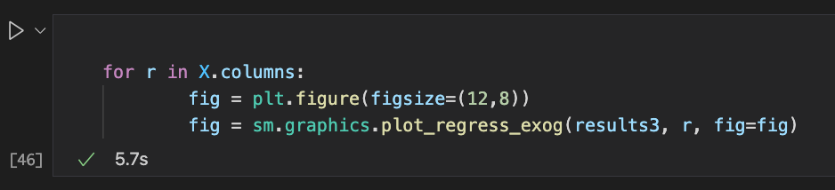

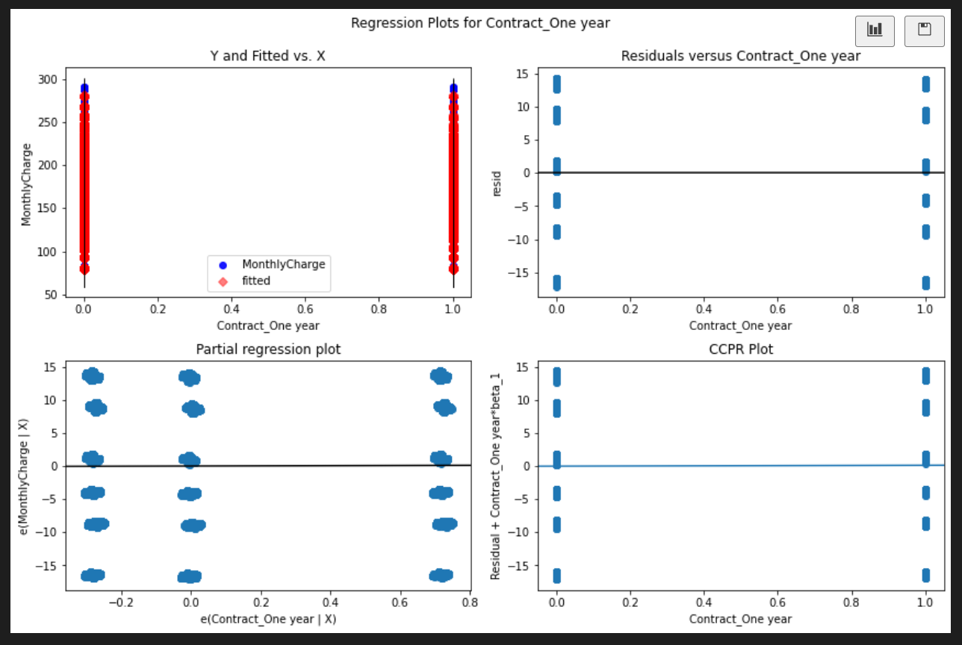

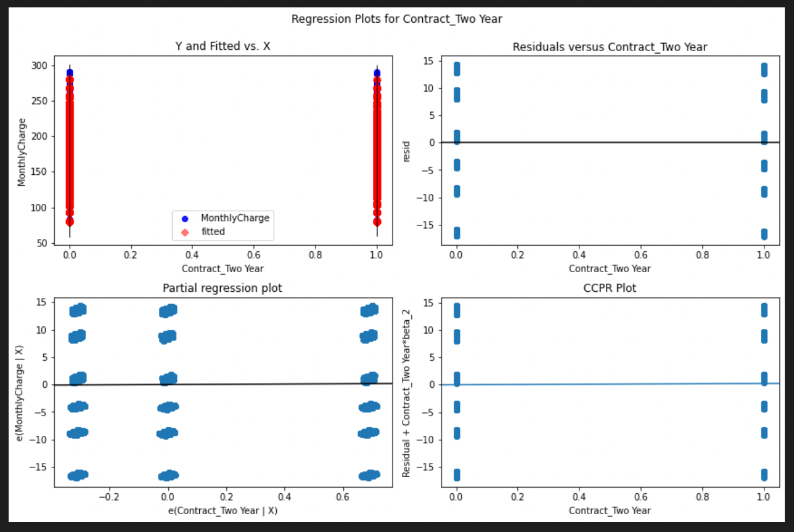

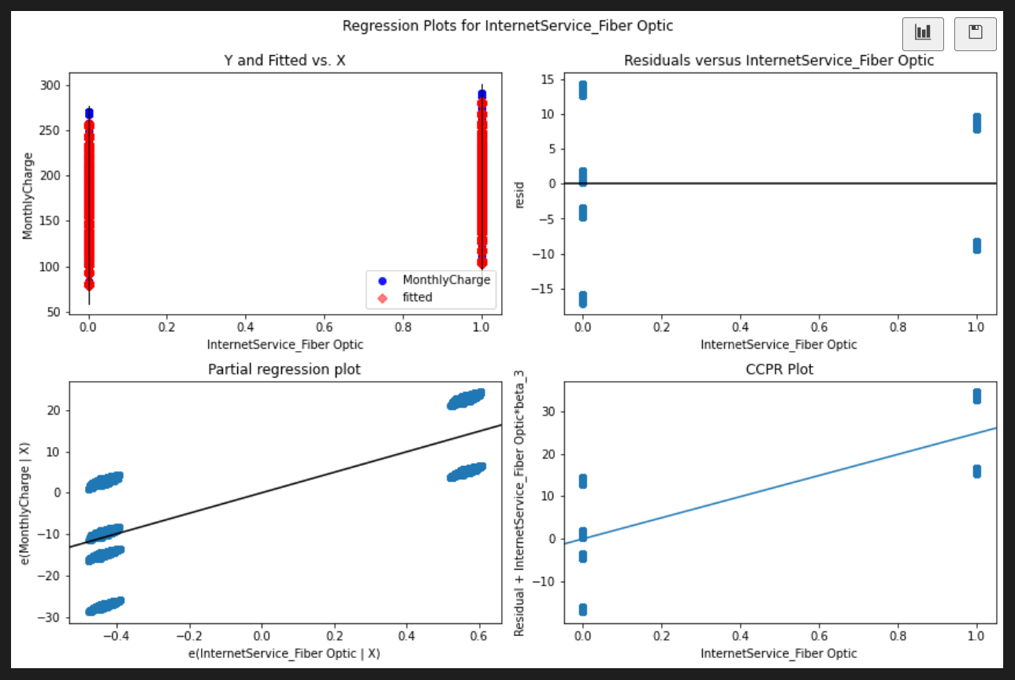

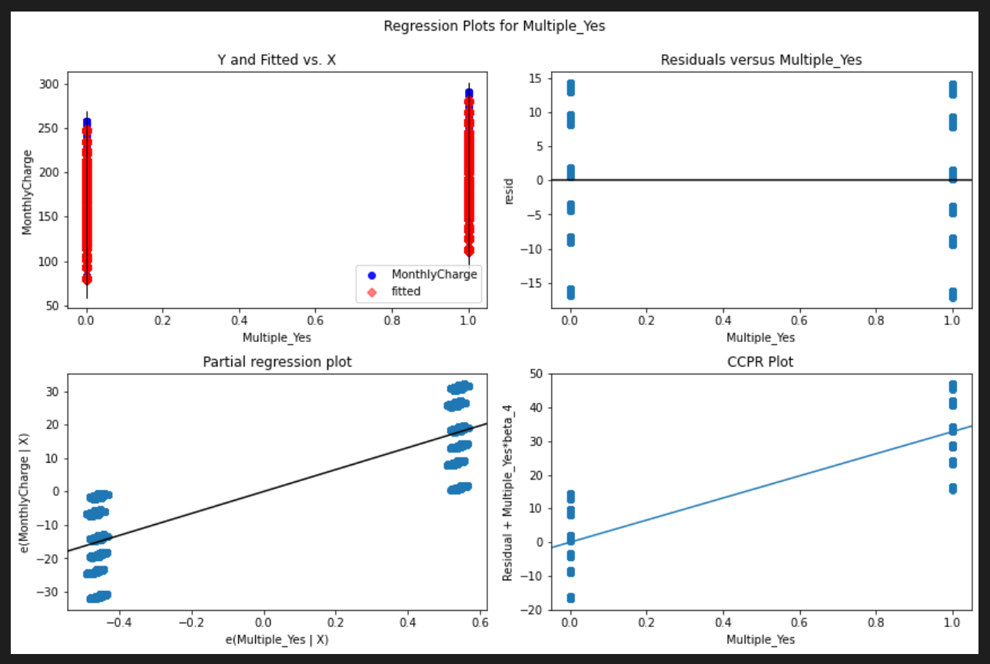

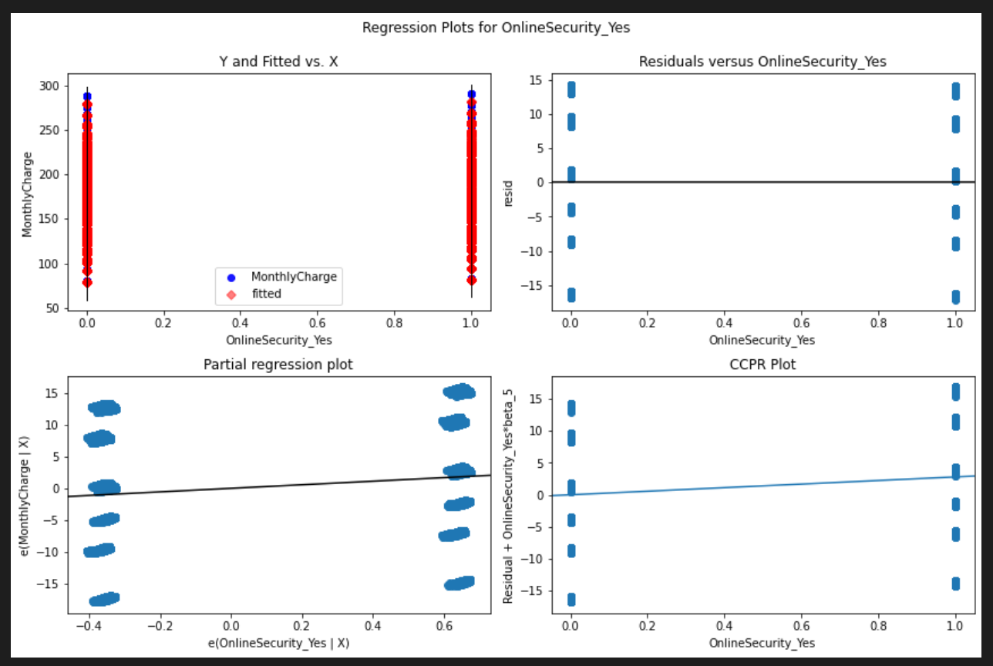

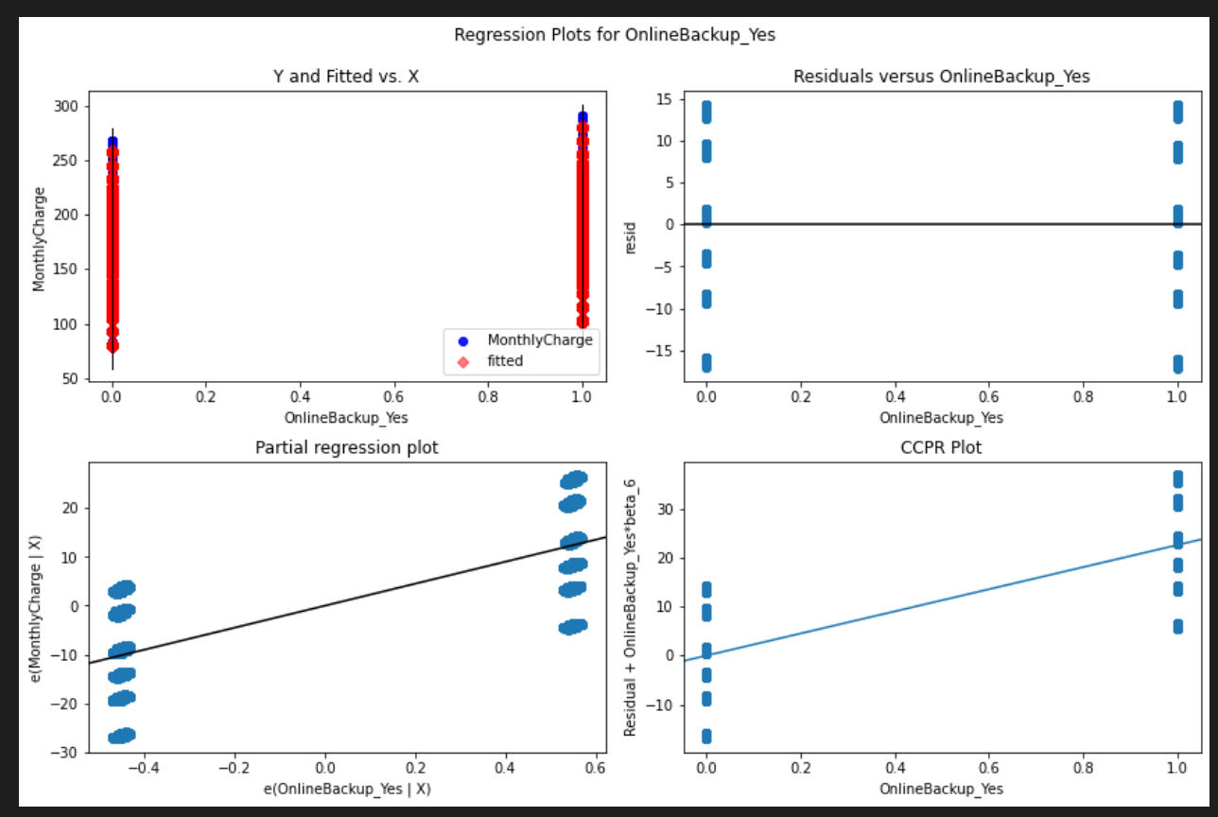

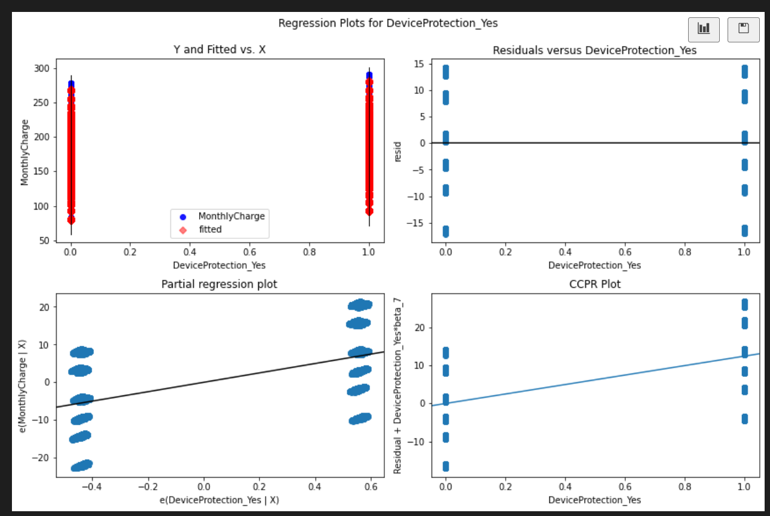

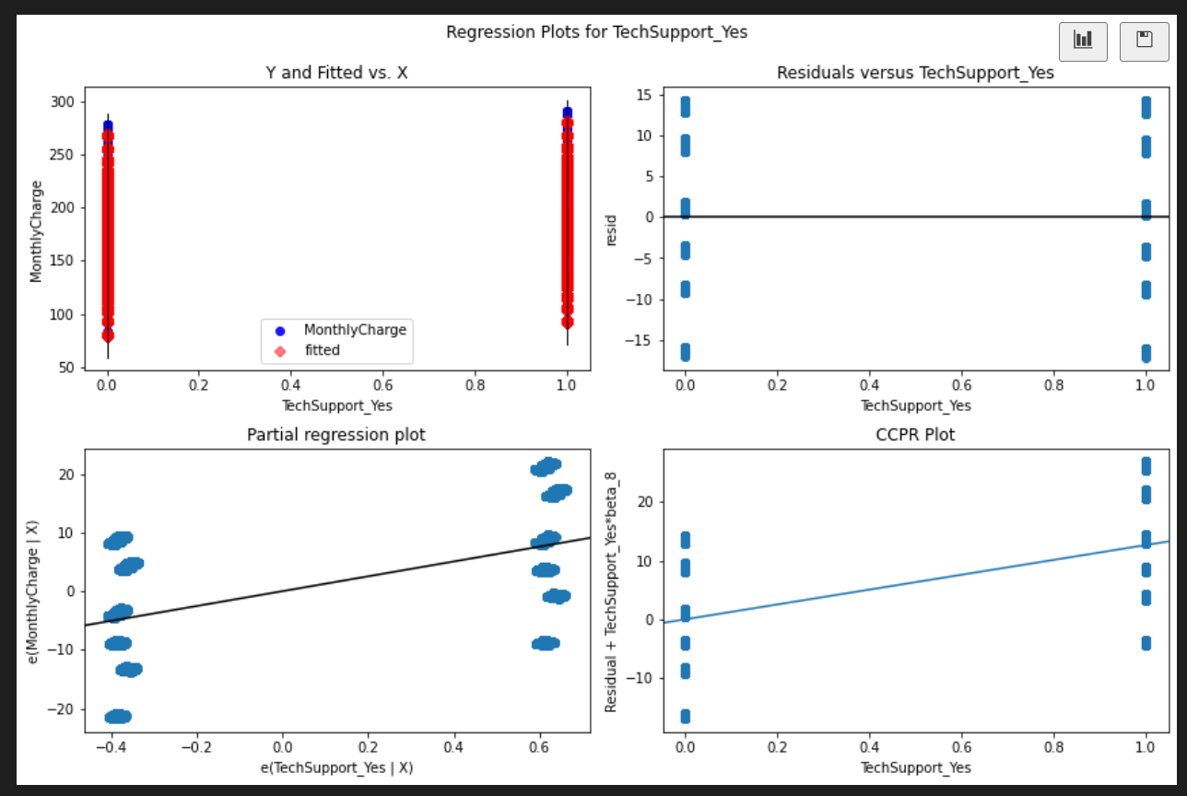

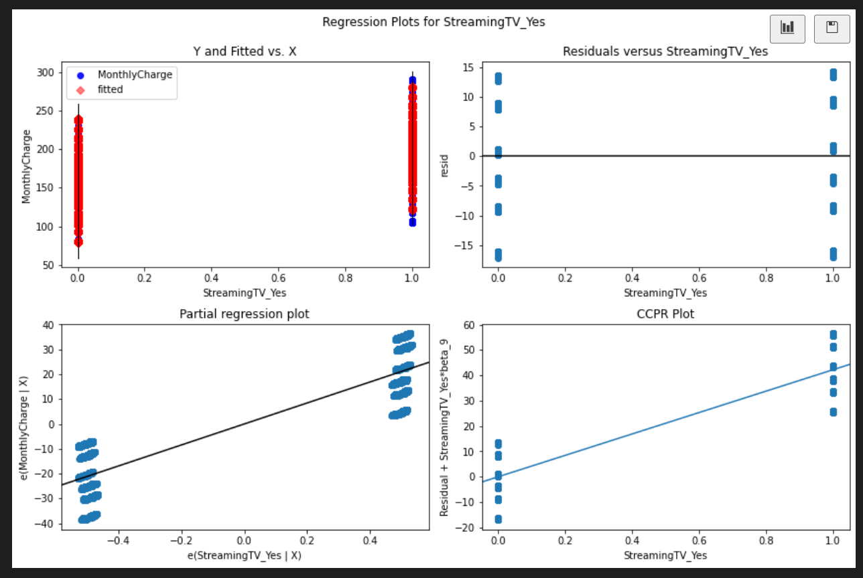

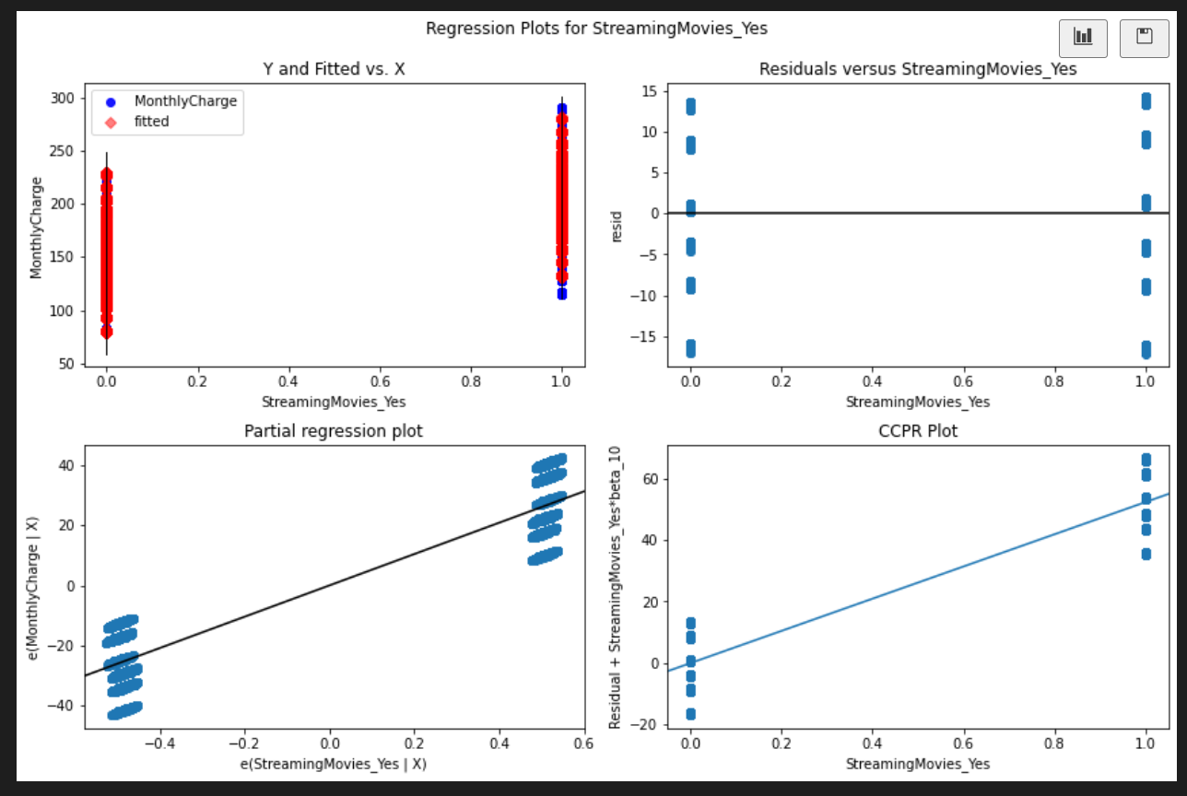

1. Provide the output and *any* calculations of the analysis you performed, including the model’s residual error. (Note: The output should include the predictions from the refined model you used to perform the analysis.)

All output and calculations screenshotted above.

1. Provide the code used to support the implementation of the multiple regression models.

All code screenshotted above.

**Part V: Data Summary and Implications**

F: Summarize your findings and assumptions by doing the following:

1. Discuss the results of your data analysis, including the following elements:
   * A regression equation for the reduced model
   * An interpretation of coefficients of the statistically significant variables of the model
   * The statistical and practical significance of the model
   * The limitations of the data analysis

The model has been regressed and is complete as far as being a proper fit to monthly charges. The services that customers purchase are the variables that are part of this model and the other variables which may have not contributed to this analysis, have been eliminated based on their p-values and multicollinearity with each other.

The regression equation for the final model is:

$$y=78.76 \left(const\right)+0.14 x \left(ContractOneYear\right)+0.23 x \left(ContractTwoYear\right)+24.74 x \left(InternetServiceFiberOptic\right)+32.80 x \left(MultipleYes\right)+2.80 x \left(OnlineSecurityYes\right)+22.58 x \left(OnlineBackupYes\right)+12.46 x \left(DeviceProtectionYes\right)+12.64 x \left(TechSupportYes\right)+42.18 x \left(StreamingTVYes\right)+52.34 x (StreamingMoviesYes)$$

This model has a total of 10 predictor variables, the R2 value is 0.946, and the condition number is 6. This indicates a good model and fit for explaining variability.

The equation can accurately predict the monthly charge of a customer depending on the different services that they customer has purchased.

The variables selected show statistical significance through their p-values and low multicollinearity. The model shows a reliability in being able to predict and explain customer churn. The interpretation of the coefficients is that the base price for most customers is $78.76. Extra add-on feature prices can be determined by the coefficients of those respective variables. For example, if someone purchased online security ($2.80), we can assume they also purchased fiber optic internet service ($24.74) so we could estimate that the monthly charge for this customer would be $78.76 (base price) + $24.74 (internet) + $2.80 (online security) = $106.30/month.

The dataset was healthy in that there were no missing datapoints or abhorrent outliers, and variability of the dataset was thorough. The limitations of the data analysis include having a larger dataset. Another limitation would be to evaluate the competition by having new customers report how much their monthly bill was at the previous company they were with. This would help understand the competition in the market so that prices can be adjusted respectively.

1. Recommend a course of action based on your results.

The recommendation to this business would be to use this regression equation to evaluate the monthly charge for a customer. The base charge (const) is $78.76 so any additional services will add on to that. Since the business can estimate a customer’s monthly charge based on the services purchased, it would behoove them to incorporate some type of discount promotional.

**Part VI: Demonstration**

G: Provide a Panopto video recording that includes *all* of the following elements:

* a demonstration of the functionality of the code used for the analysis
* an identification of the version of the programming environment
* a comparison of the **two** multiple regression models you used in your analysis
* an interpretation of the coefficients

(Note: The audiovisual recording should feature you visibly presenting the material (i.e., not in voiceover or embedded video) and should simultaneously capture both you and your multimedia presentation.)

<https://wgu.hosted.panopto.com/Panopto/Pages/Viewer.aspx?id=a9358511-dc32-4c9d-a0f4-ae820088e65a>

H: List the web sources used to acquire data or segments of third-part code to support the application. Ensure the web sources are reliable.

[Regression Analysis with Python](https://realpython.com/linear-regression-in-python/)

I: Acknowledge sources, using in-text citations and references, for content that is quoted paraphrased, or summarized.

n/a

J: Demonstrate professional communication in the content and presentation of your submission.

n/a